Quiz 1

Which of the following are legal entry point methods that can be run form the command line?

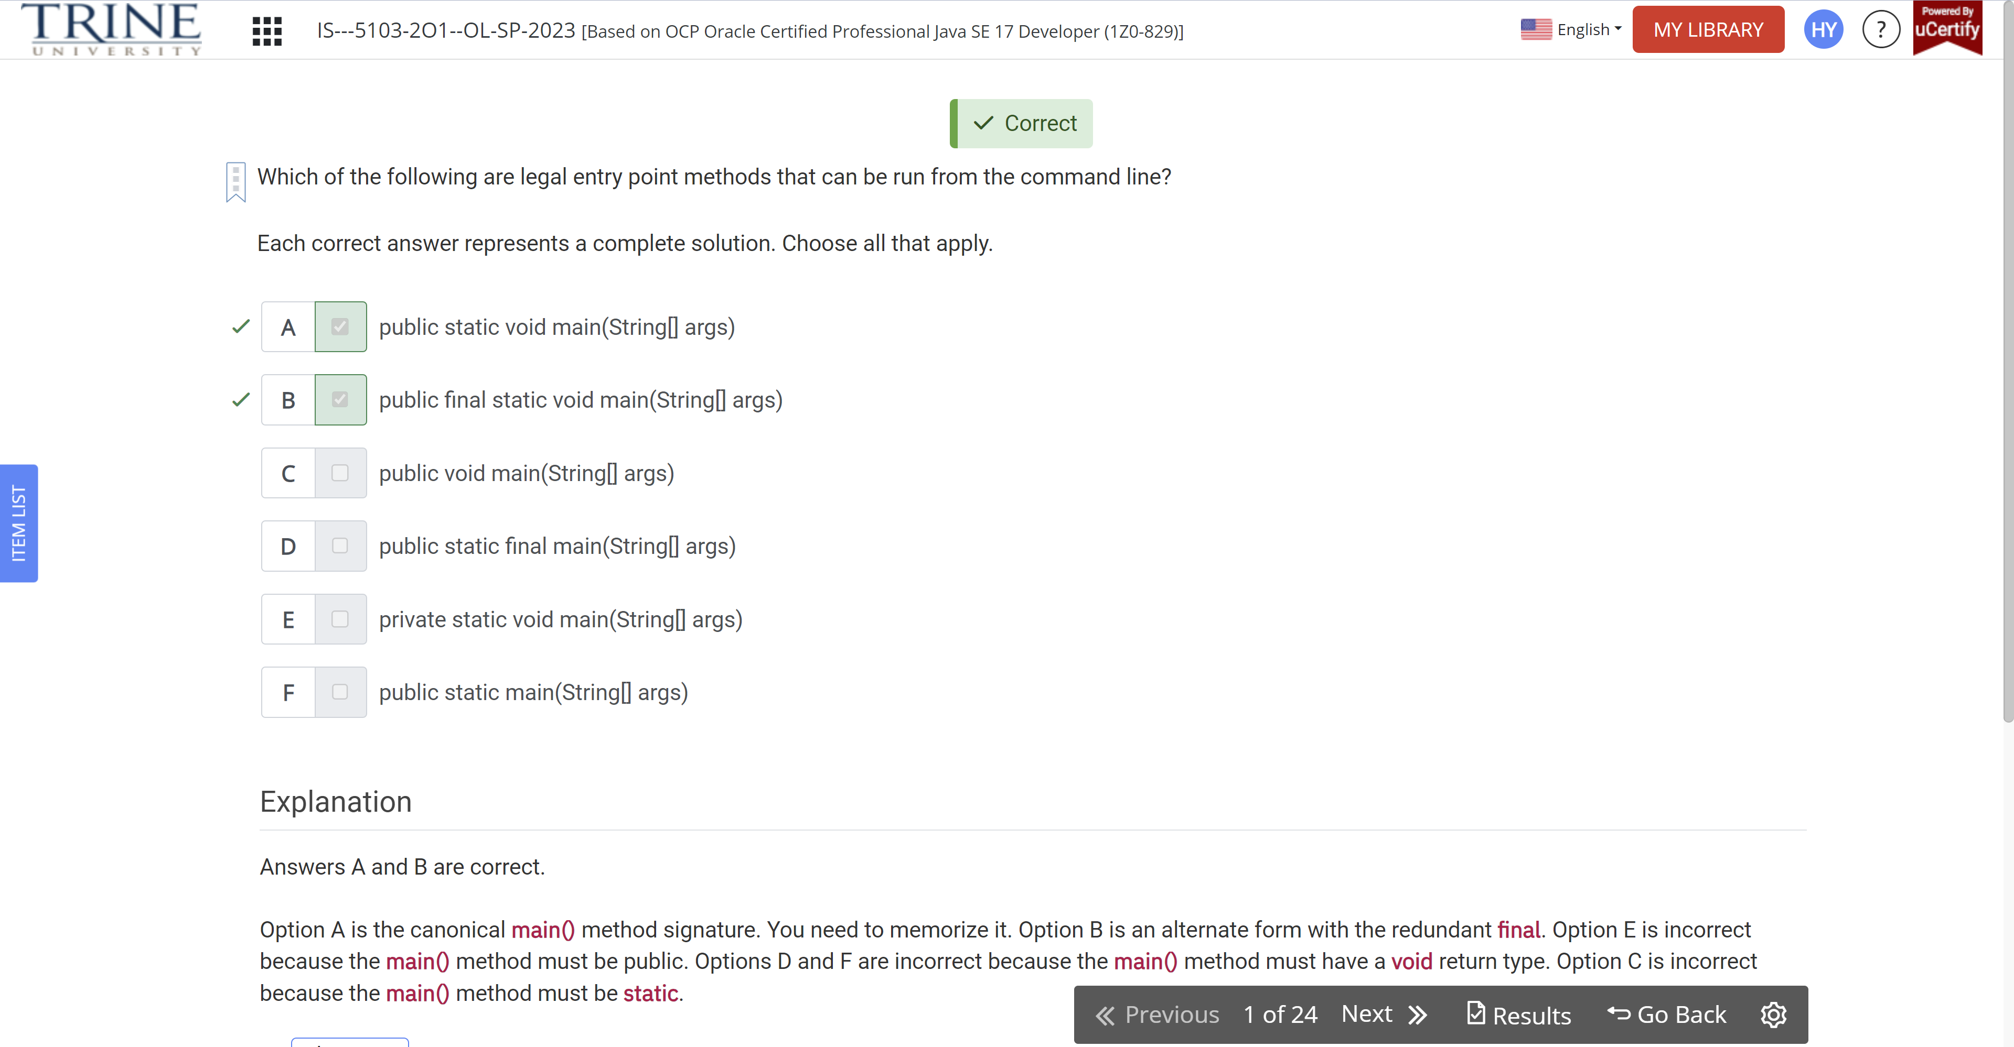

Given the following class, which of the following lines of code can independently replace INSERT CODE HERE to make the code compile?

Public class Price {…}

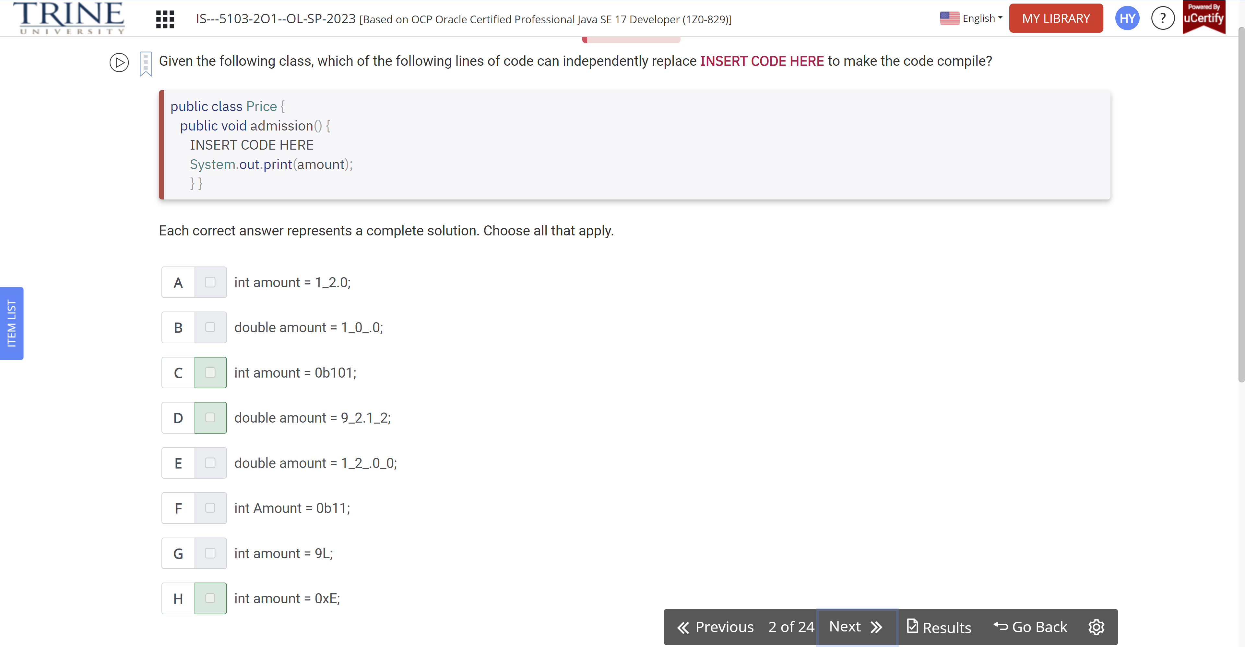

Which statement about the following class are true?

Public class River {}

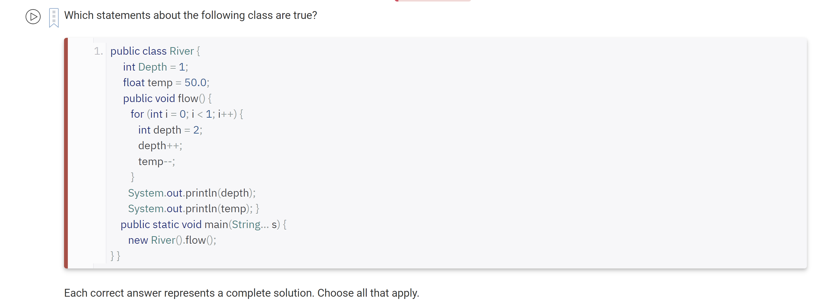

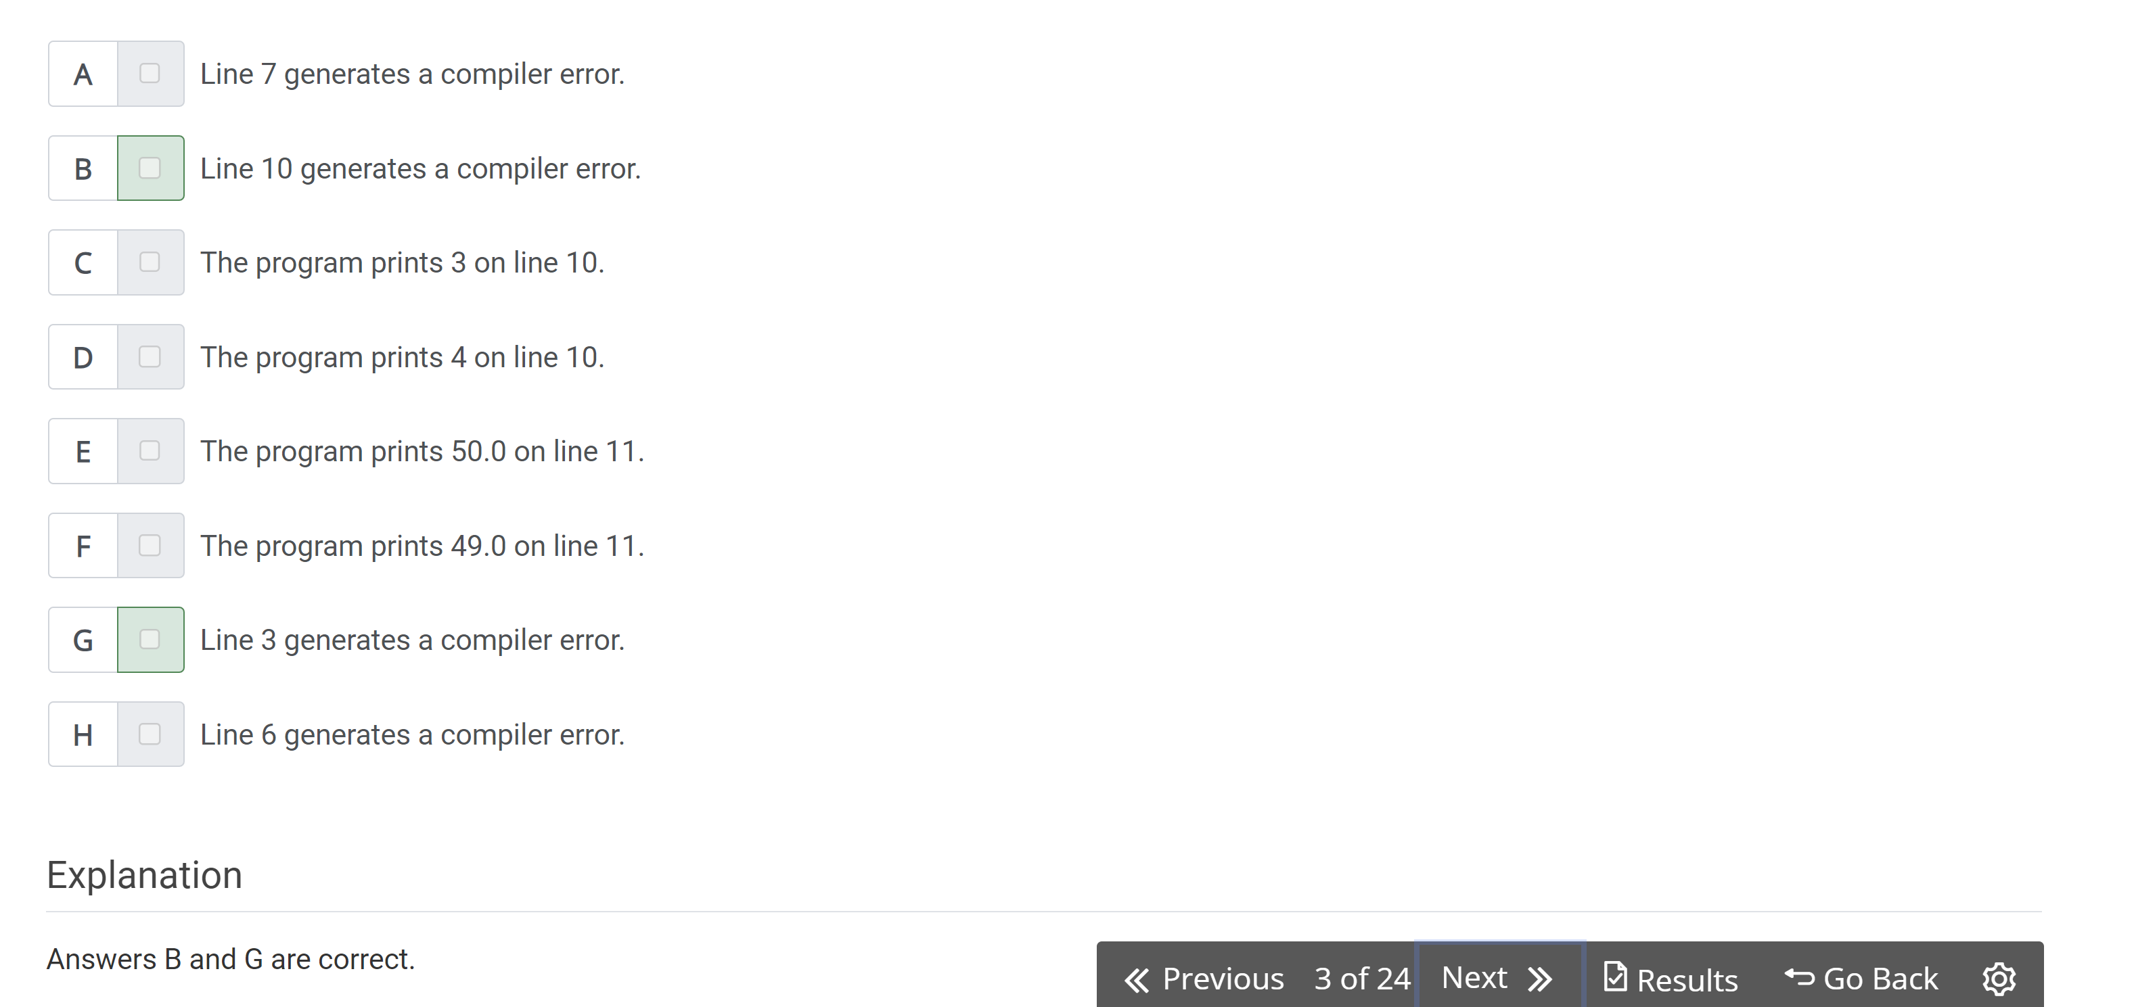

Which of the following statements about var are true?

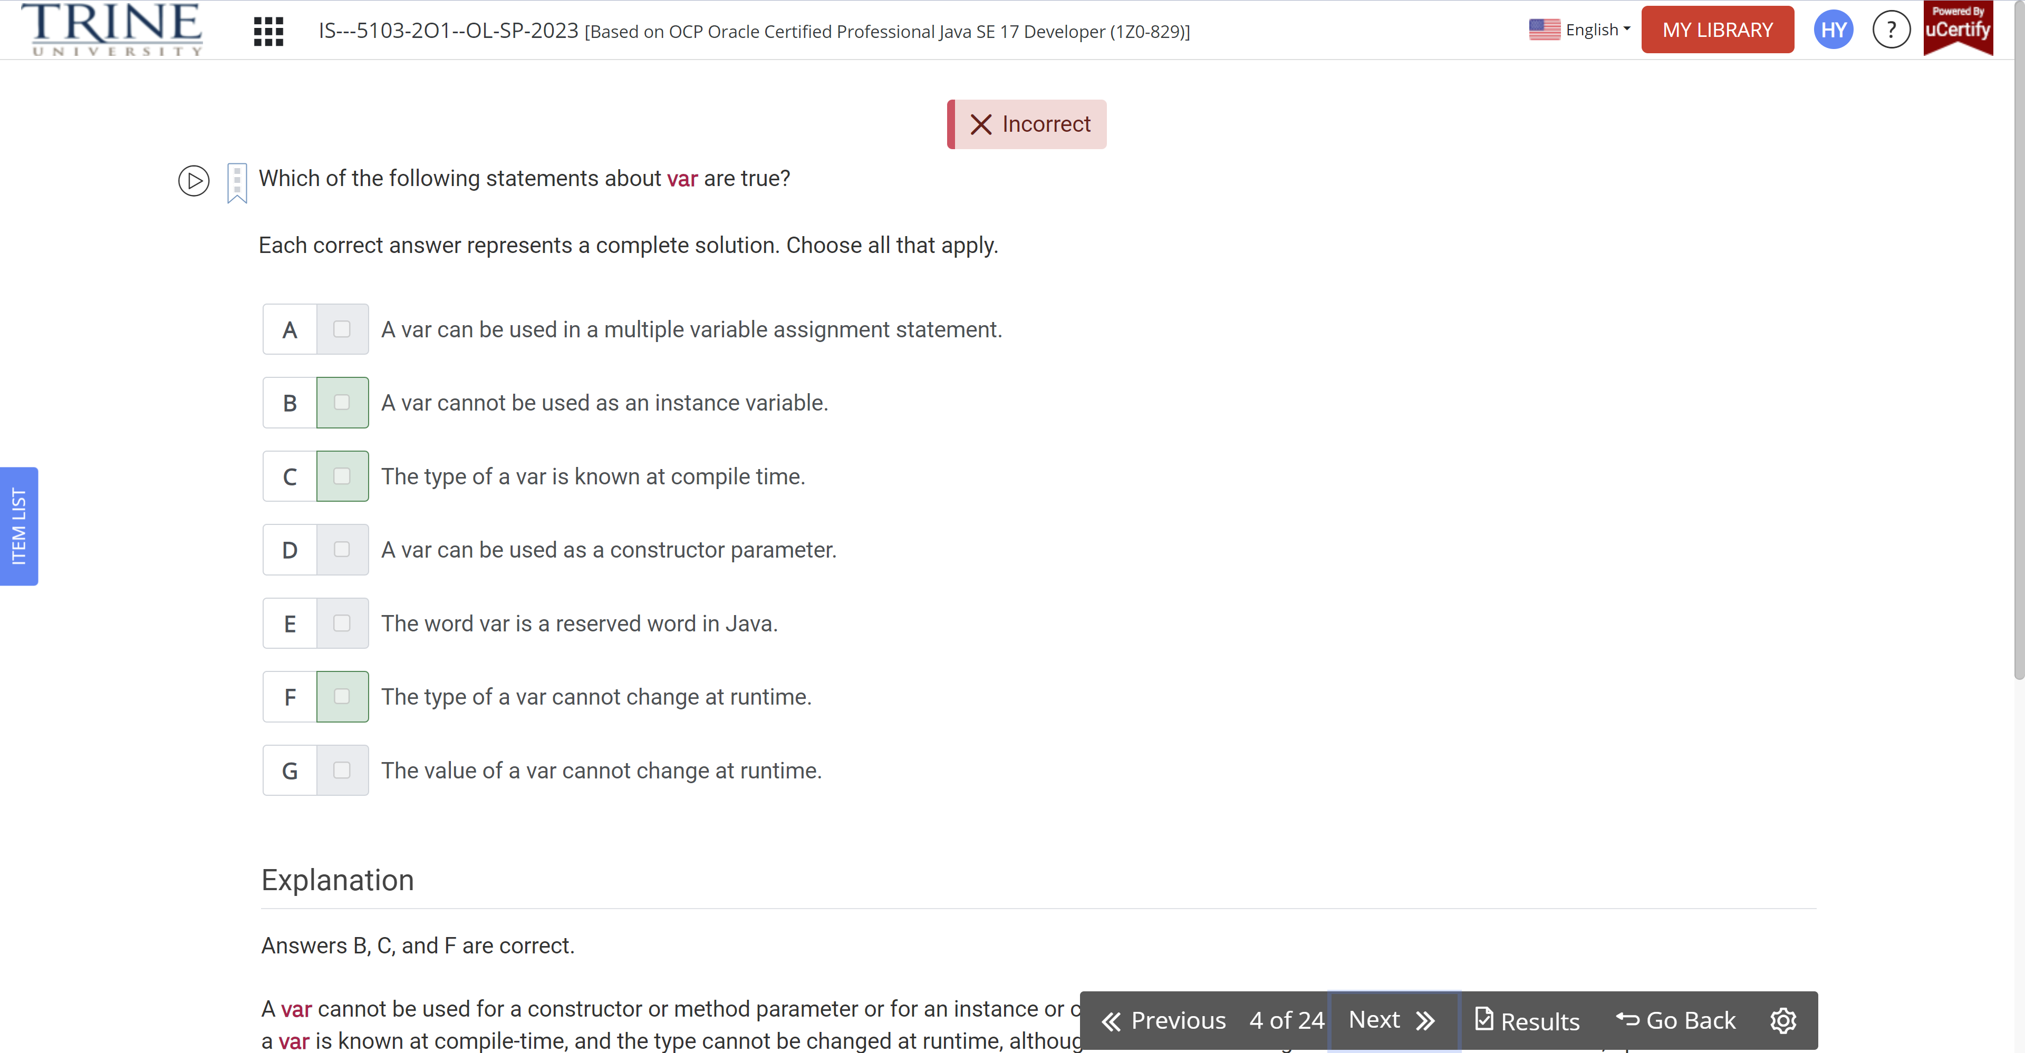

Which of the following statements about garbage collection are correct?

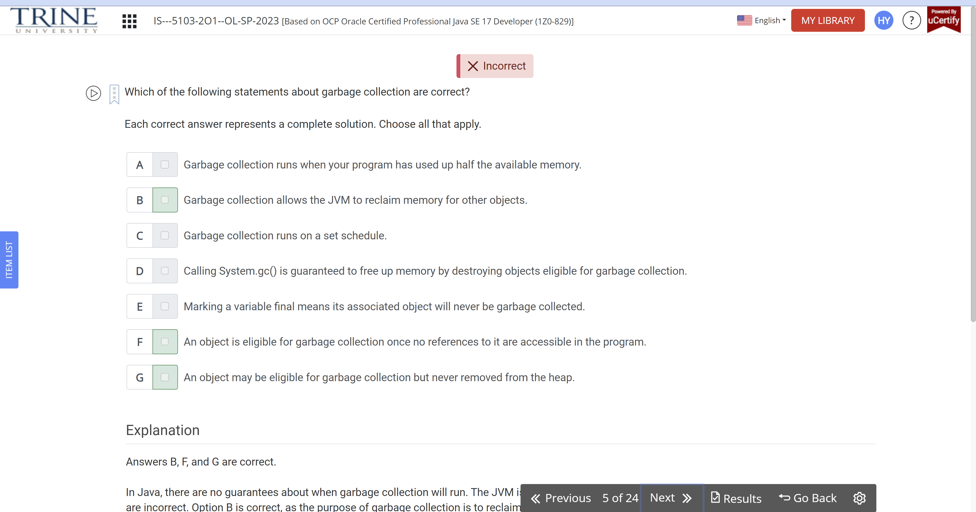

Which of the following statements about the code snippet are true?

Short numPets = 5L;

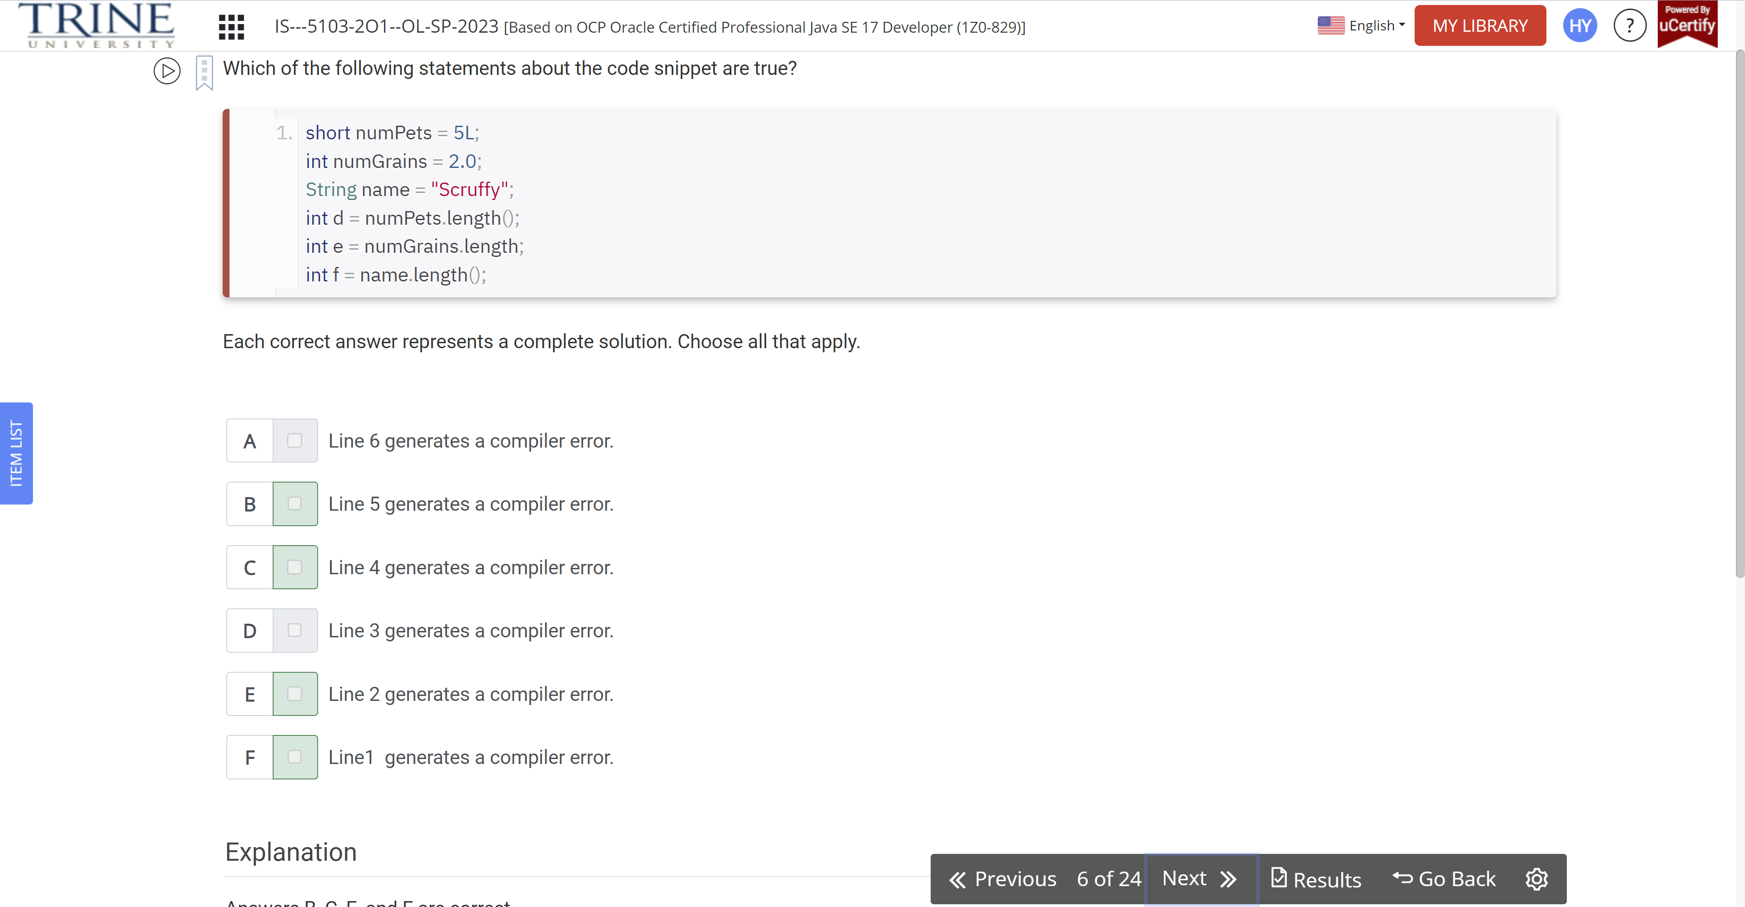

Given the following two class files, what is the maximum number of imports that can be removed and have the code still compile?

Package aquarium;

Public class Water {}

Public class Tank {}

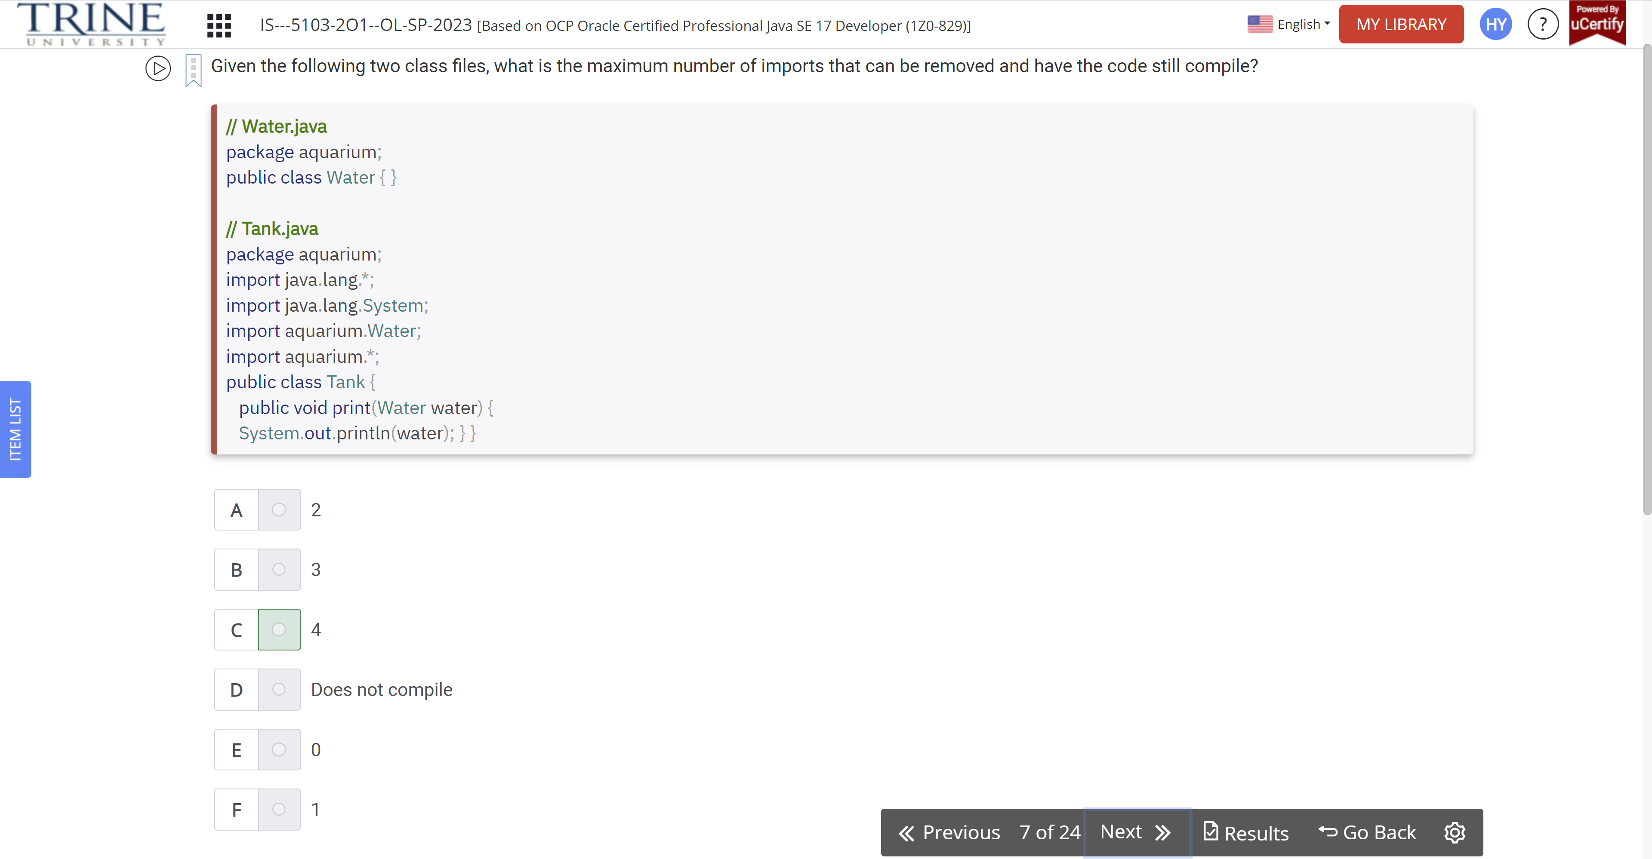

Which of the following code snippets about var compile without issue when used in a method?

Each correct answer …

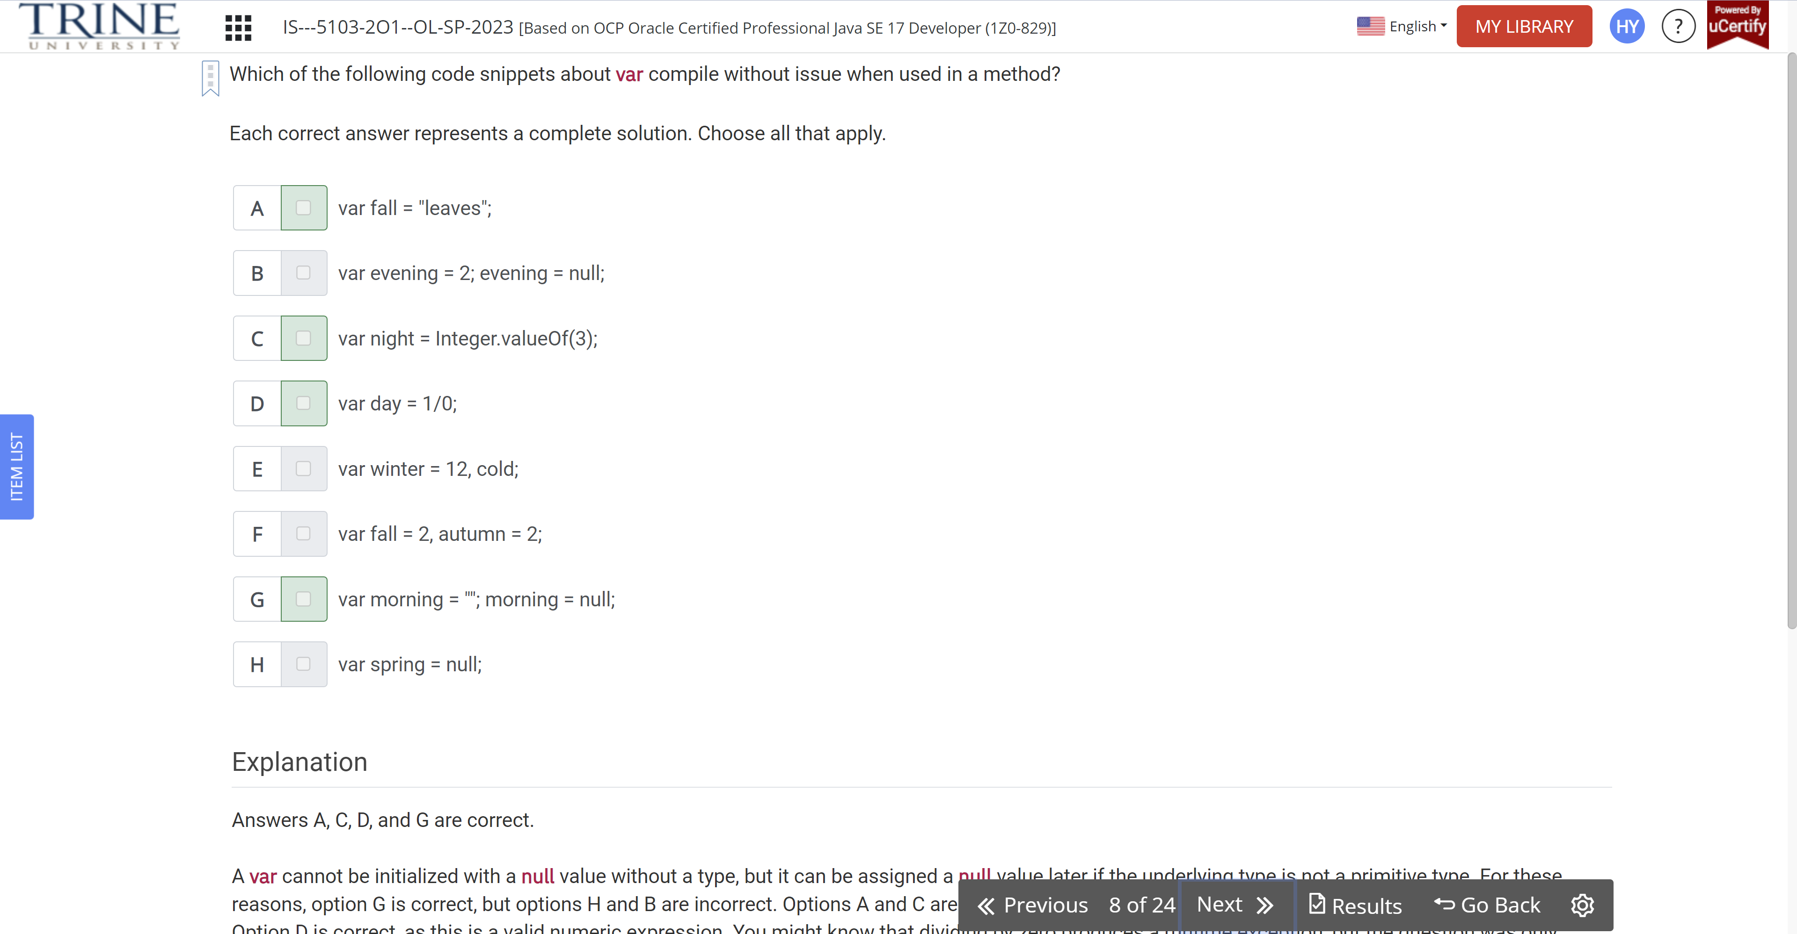

Given the following classes, which of the following snippets can independently be inserted in the place of INSERT IMPORTS HERE and have the code compile?

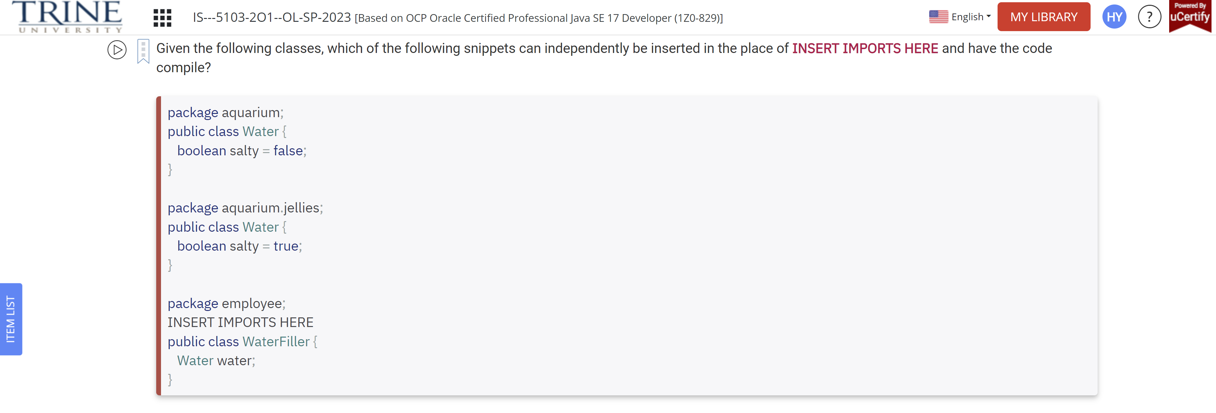

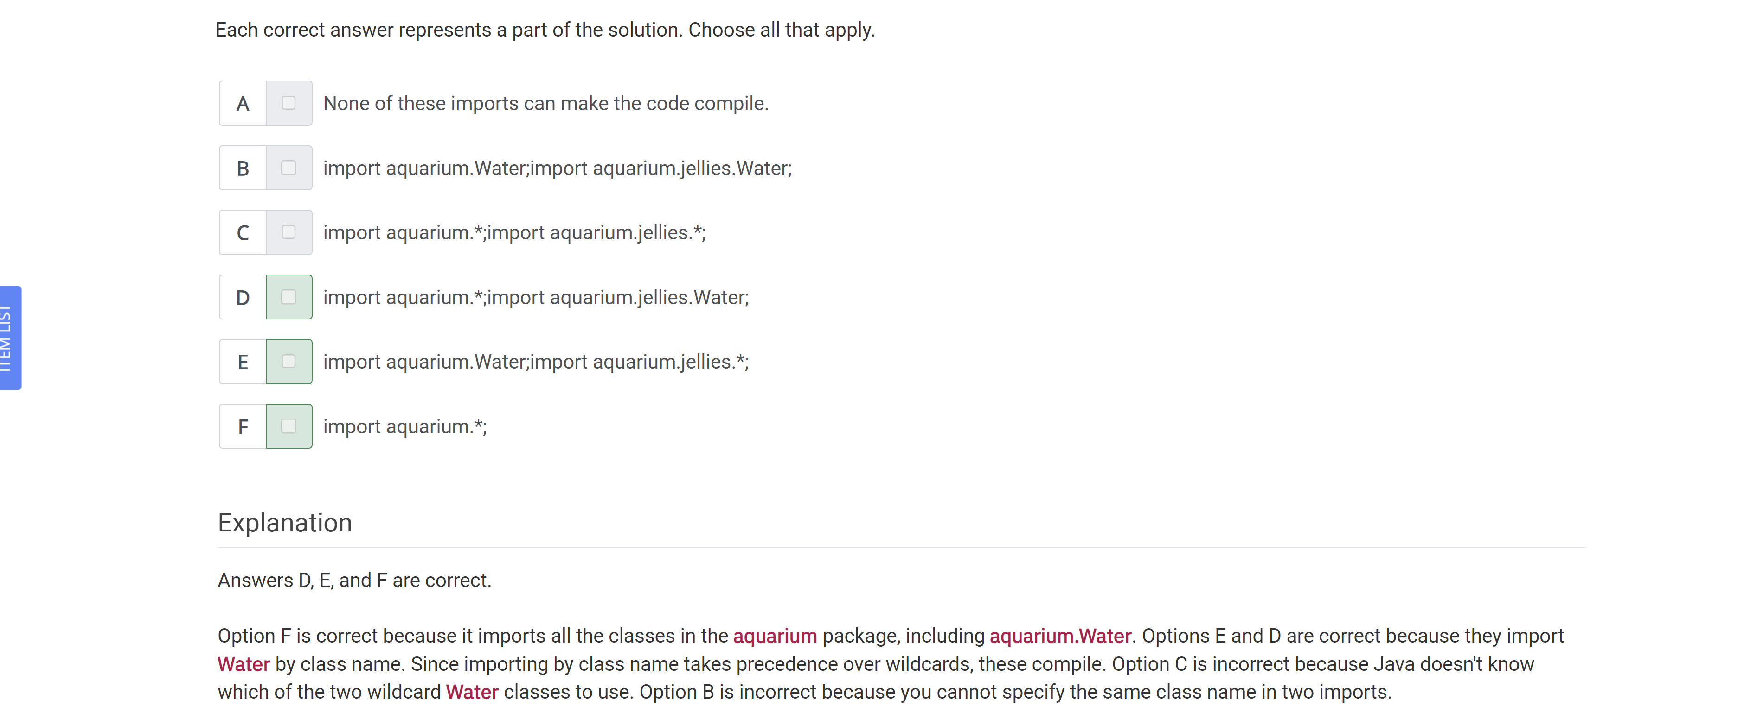

What is the output of executing the following class?

Public class Salmon {}

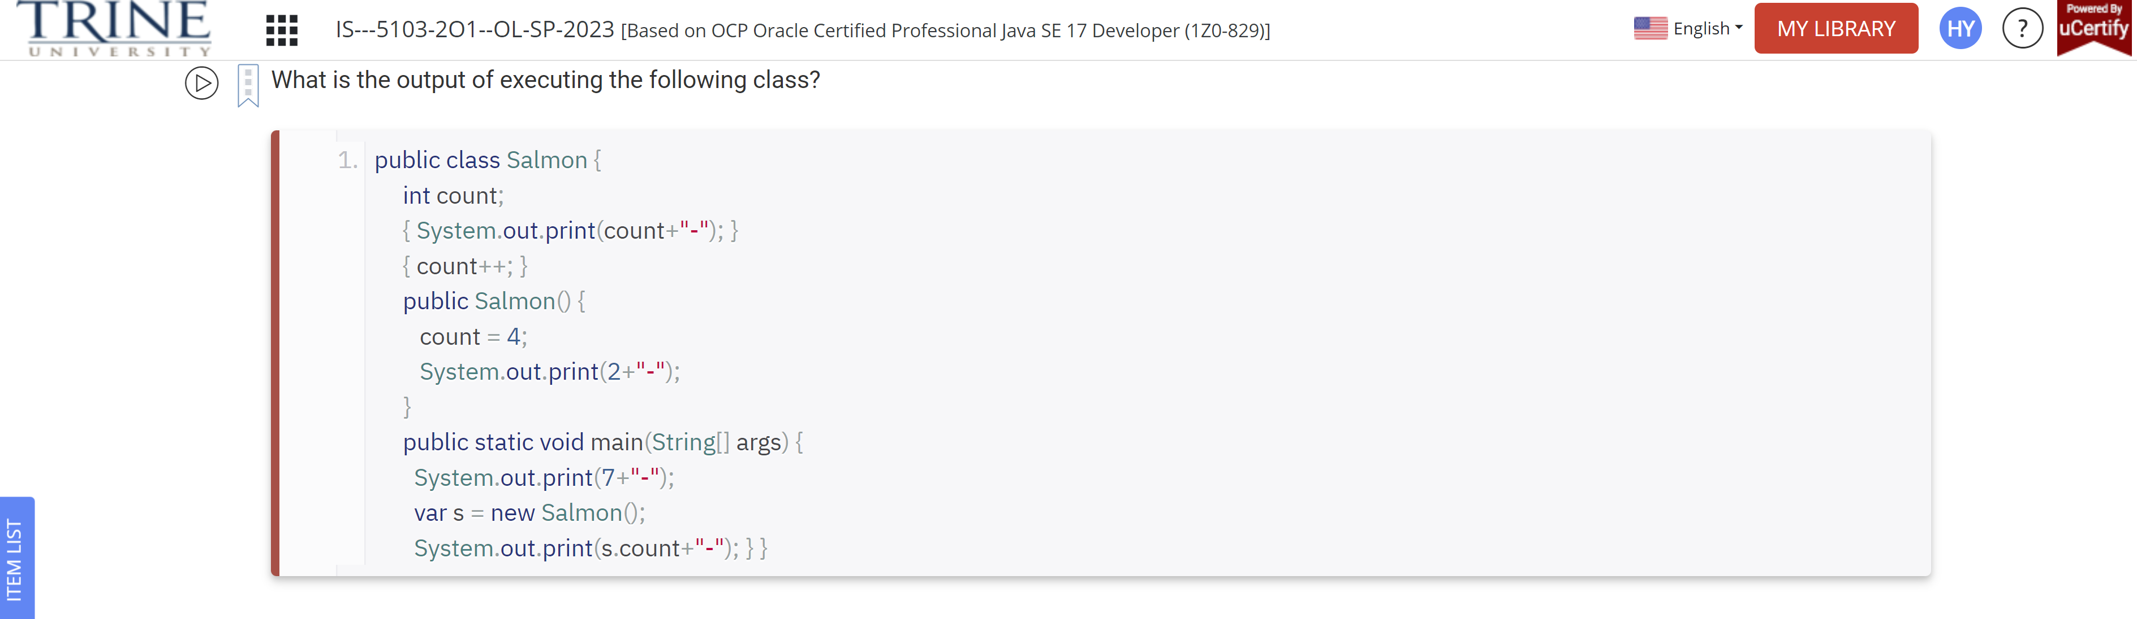

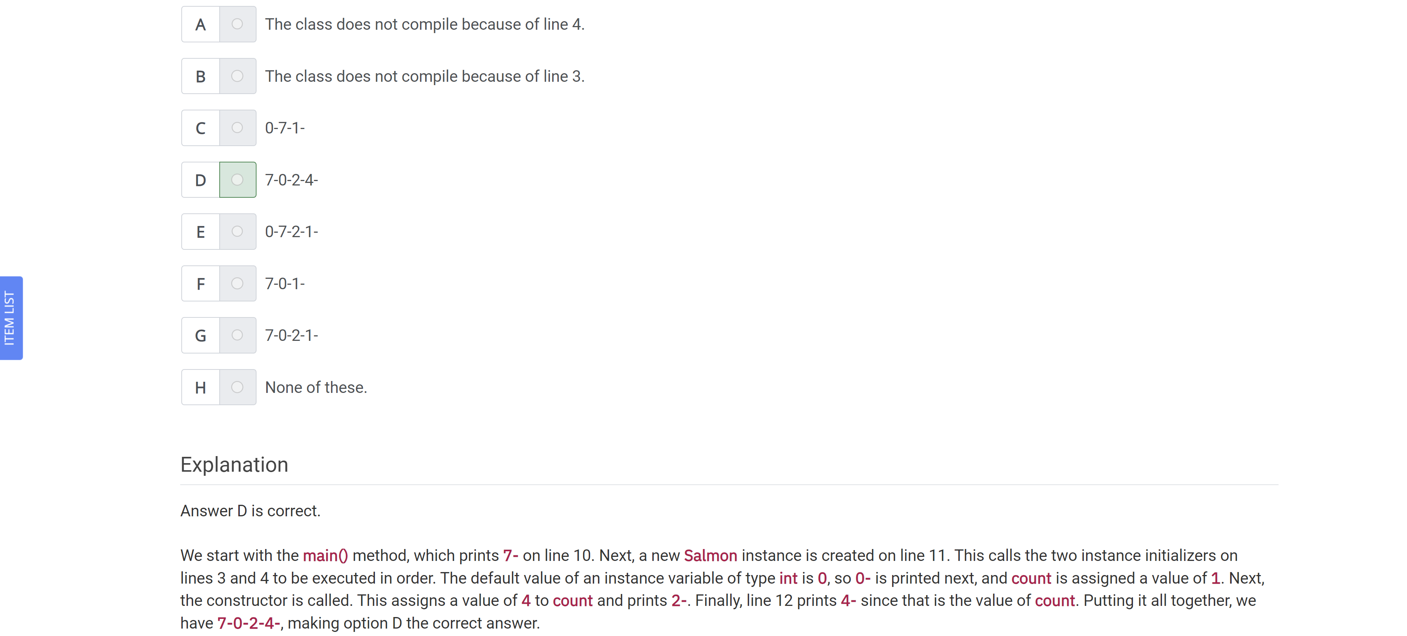

Assuming the following class compiles,how many variables defined in the class or methods are in scope on line 14?

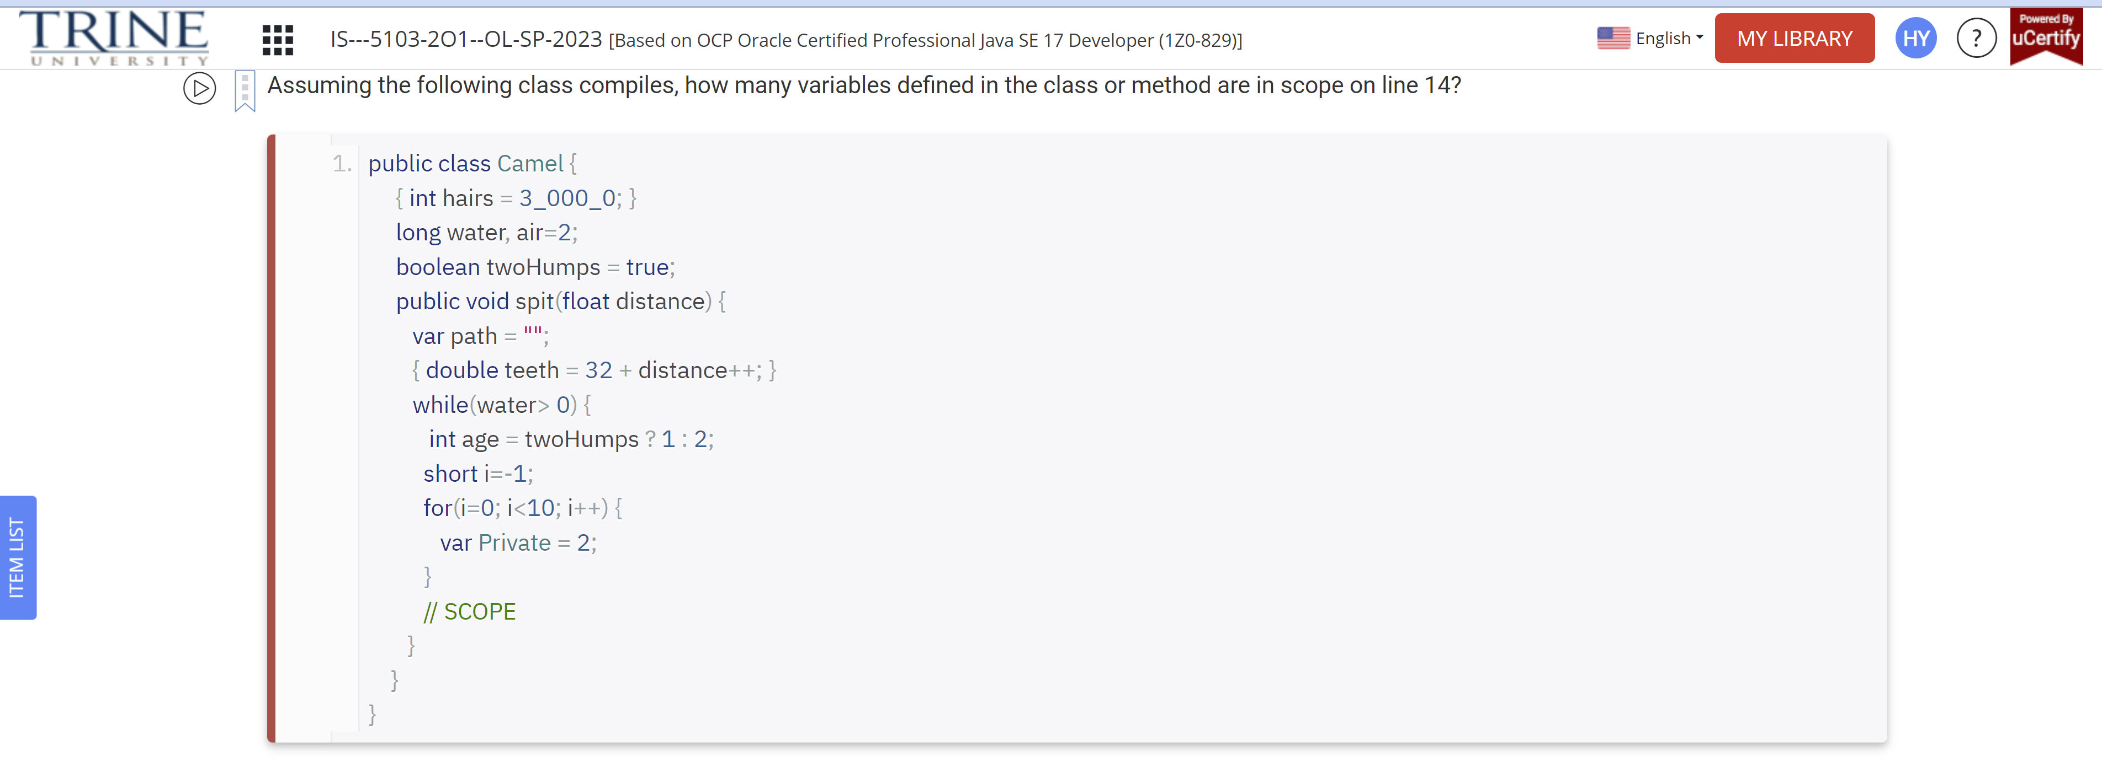

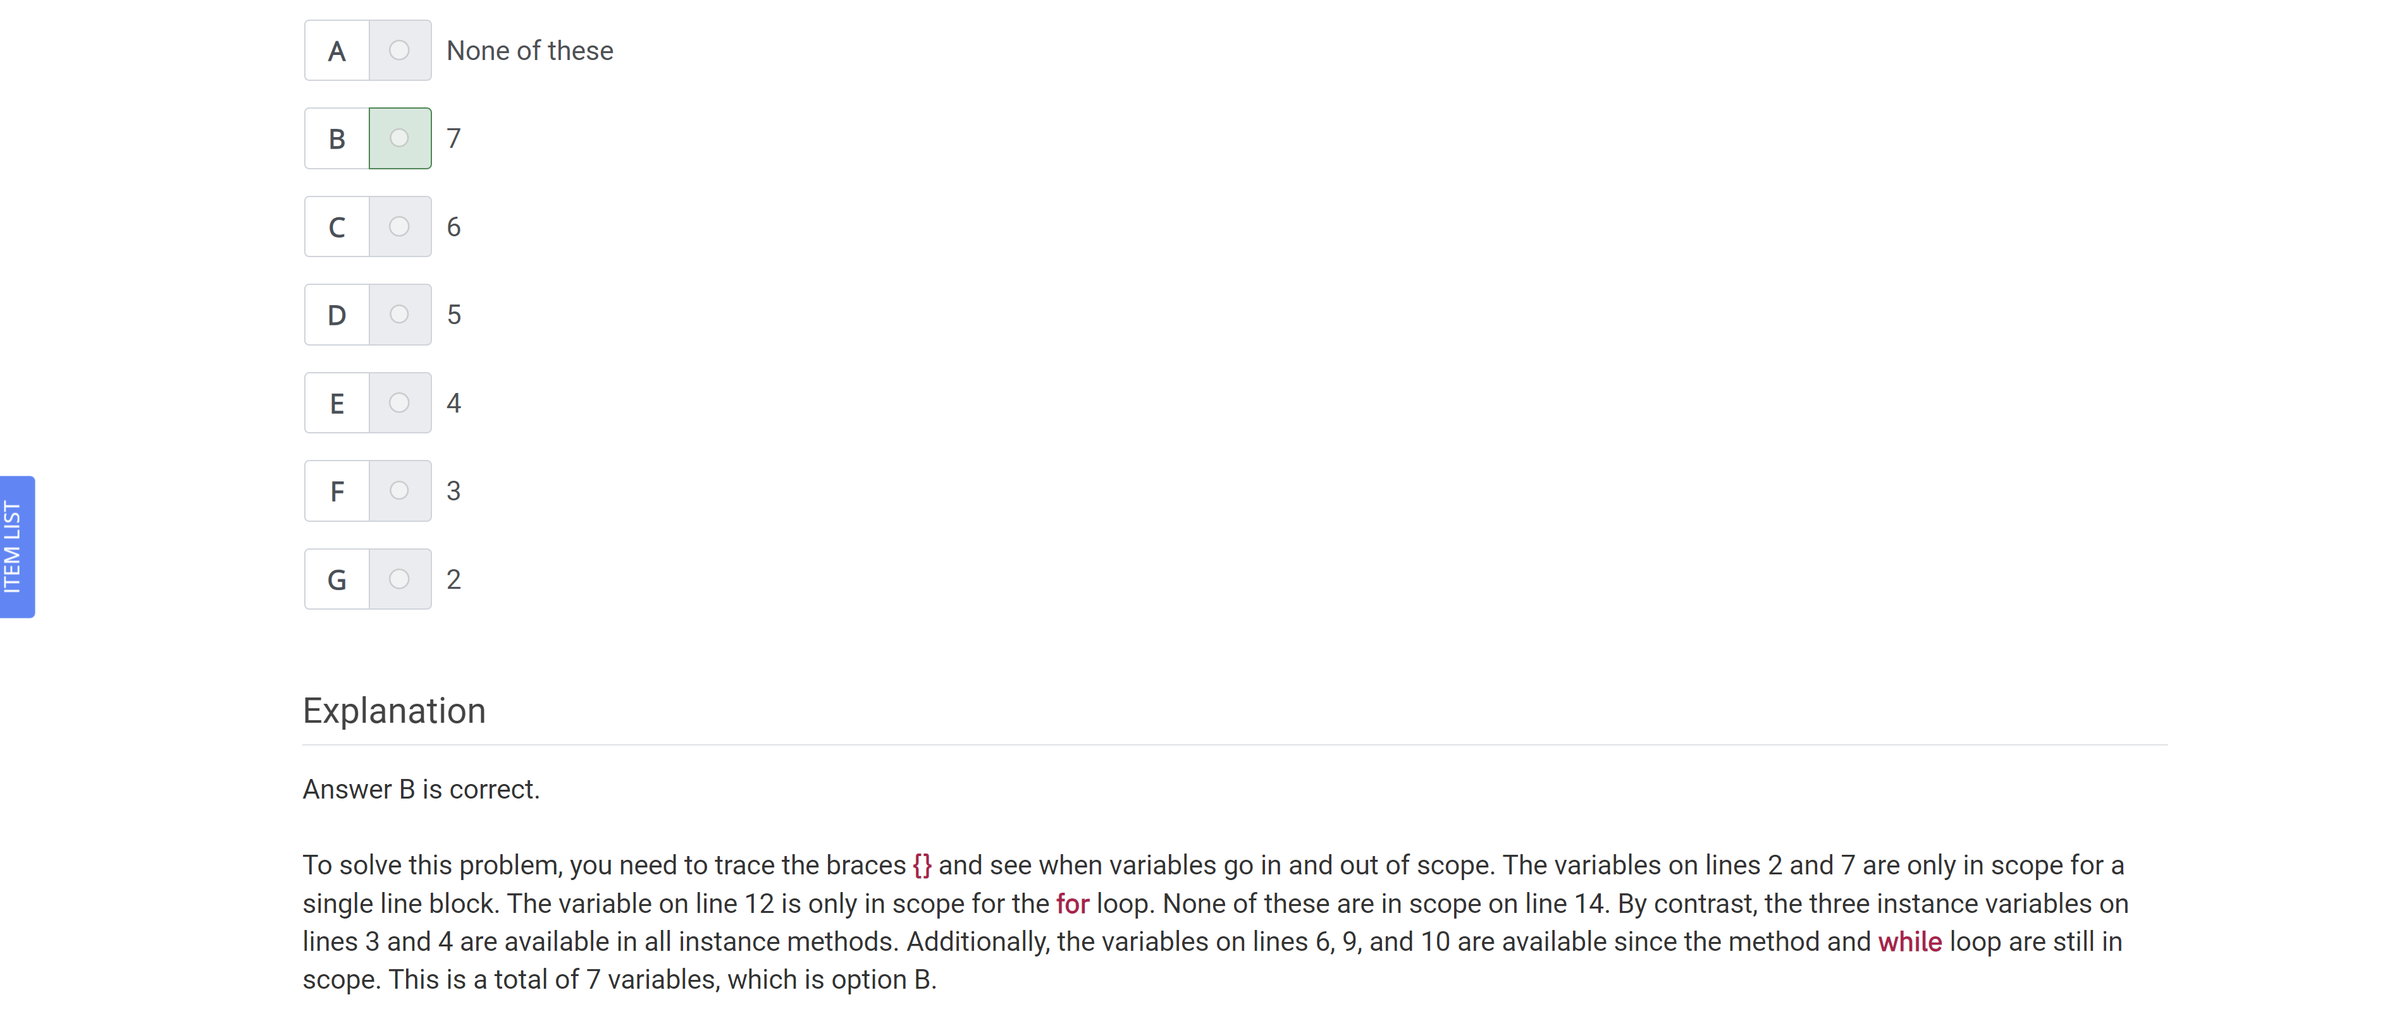

Which of the following statements are true about the code?

Var blocky = “””

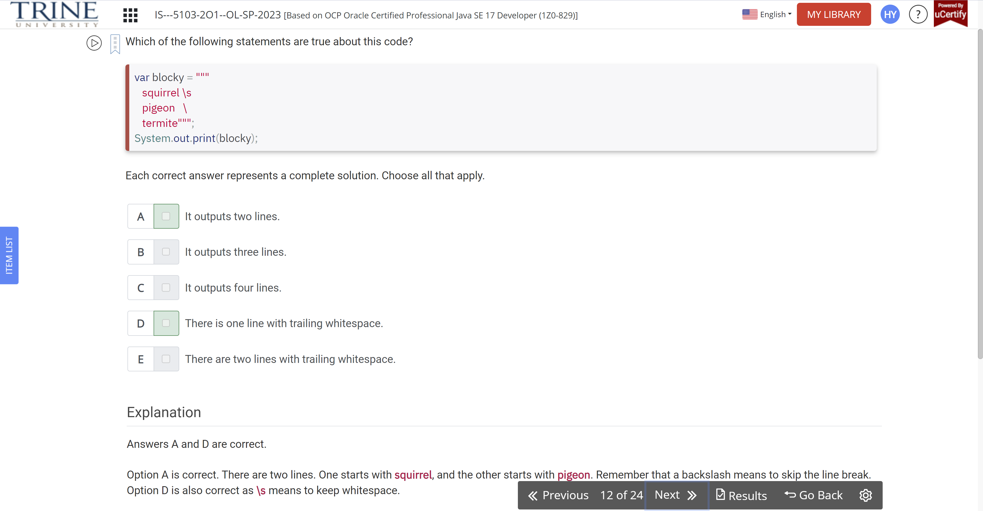

Which answer options represent the order in which the following statements can be assembled into a program that will compile successfully?

X: class Rabbit{}

Y: import java.util.\*;

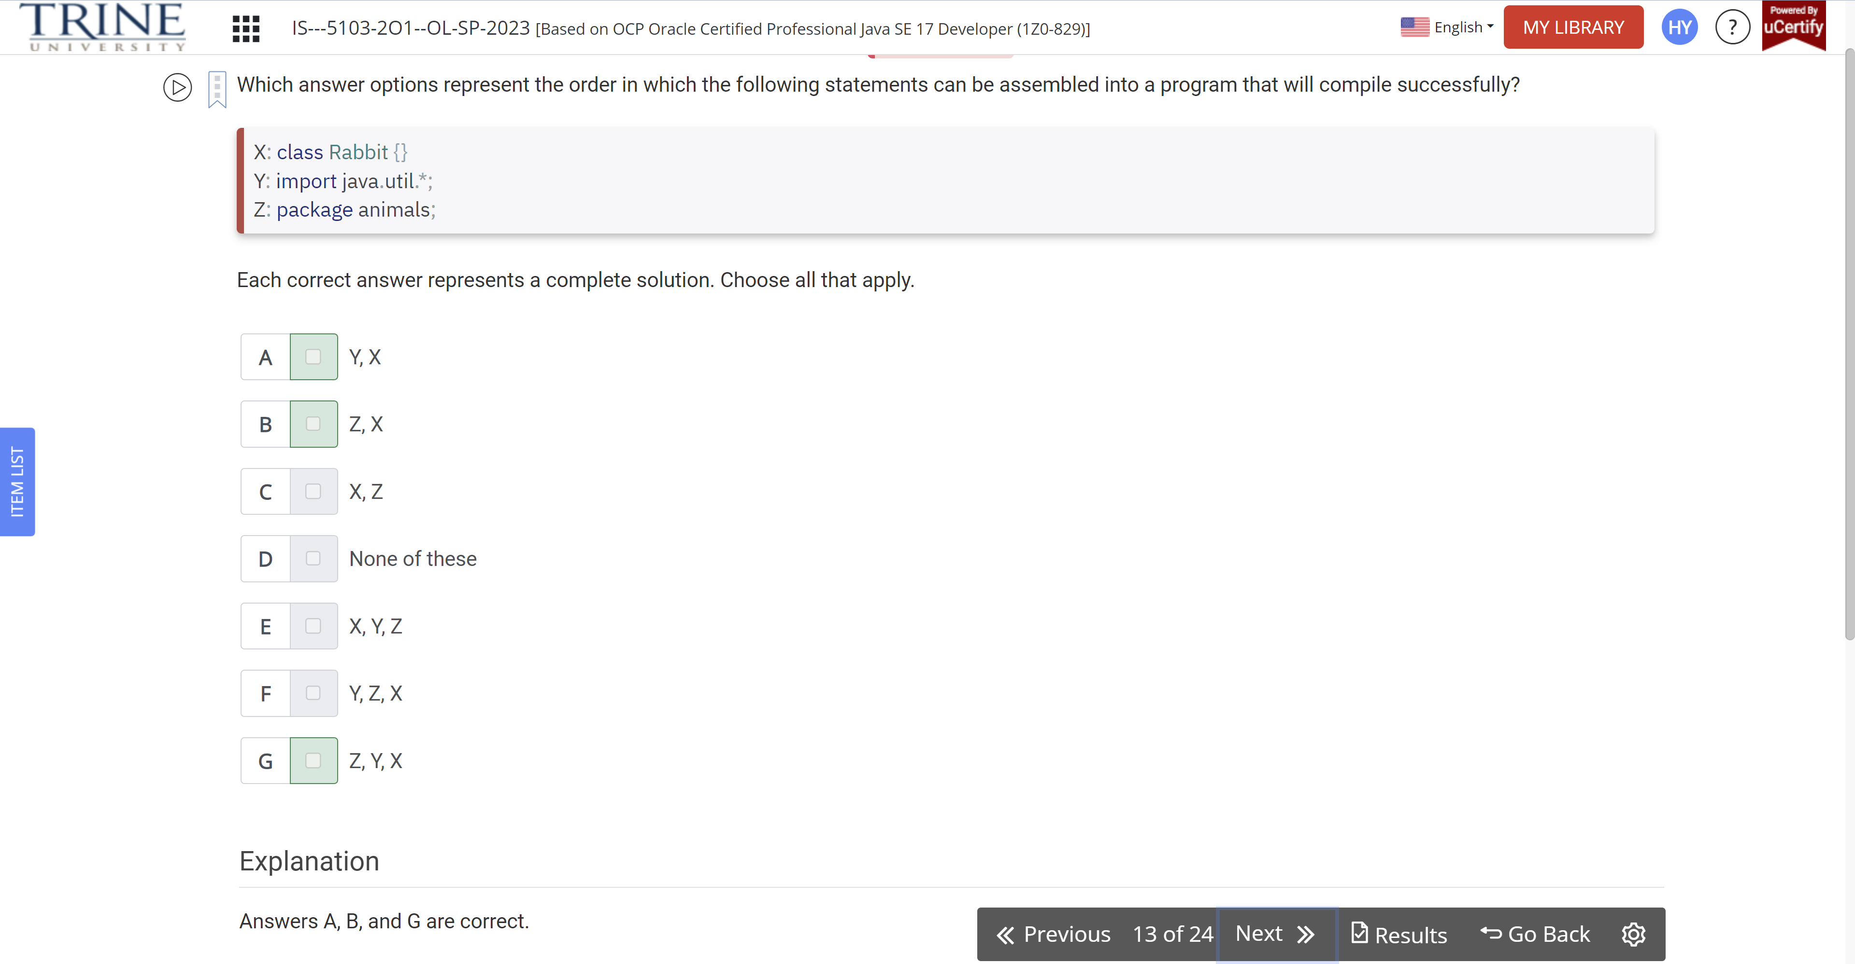

Which statement about the following class is correct?

Public class PoliceBox {…}

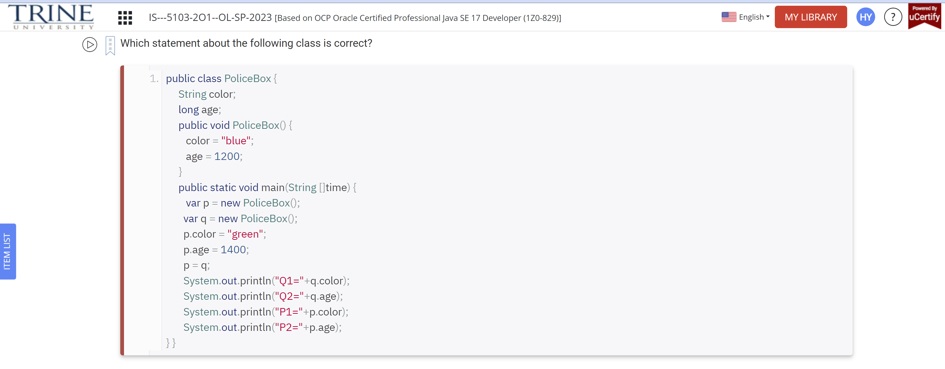

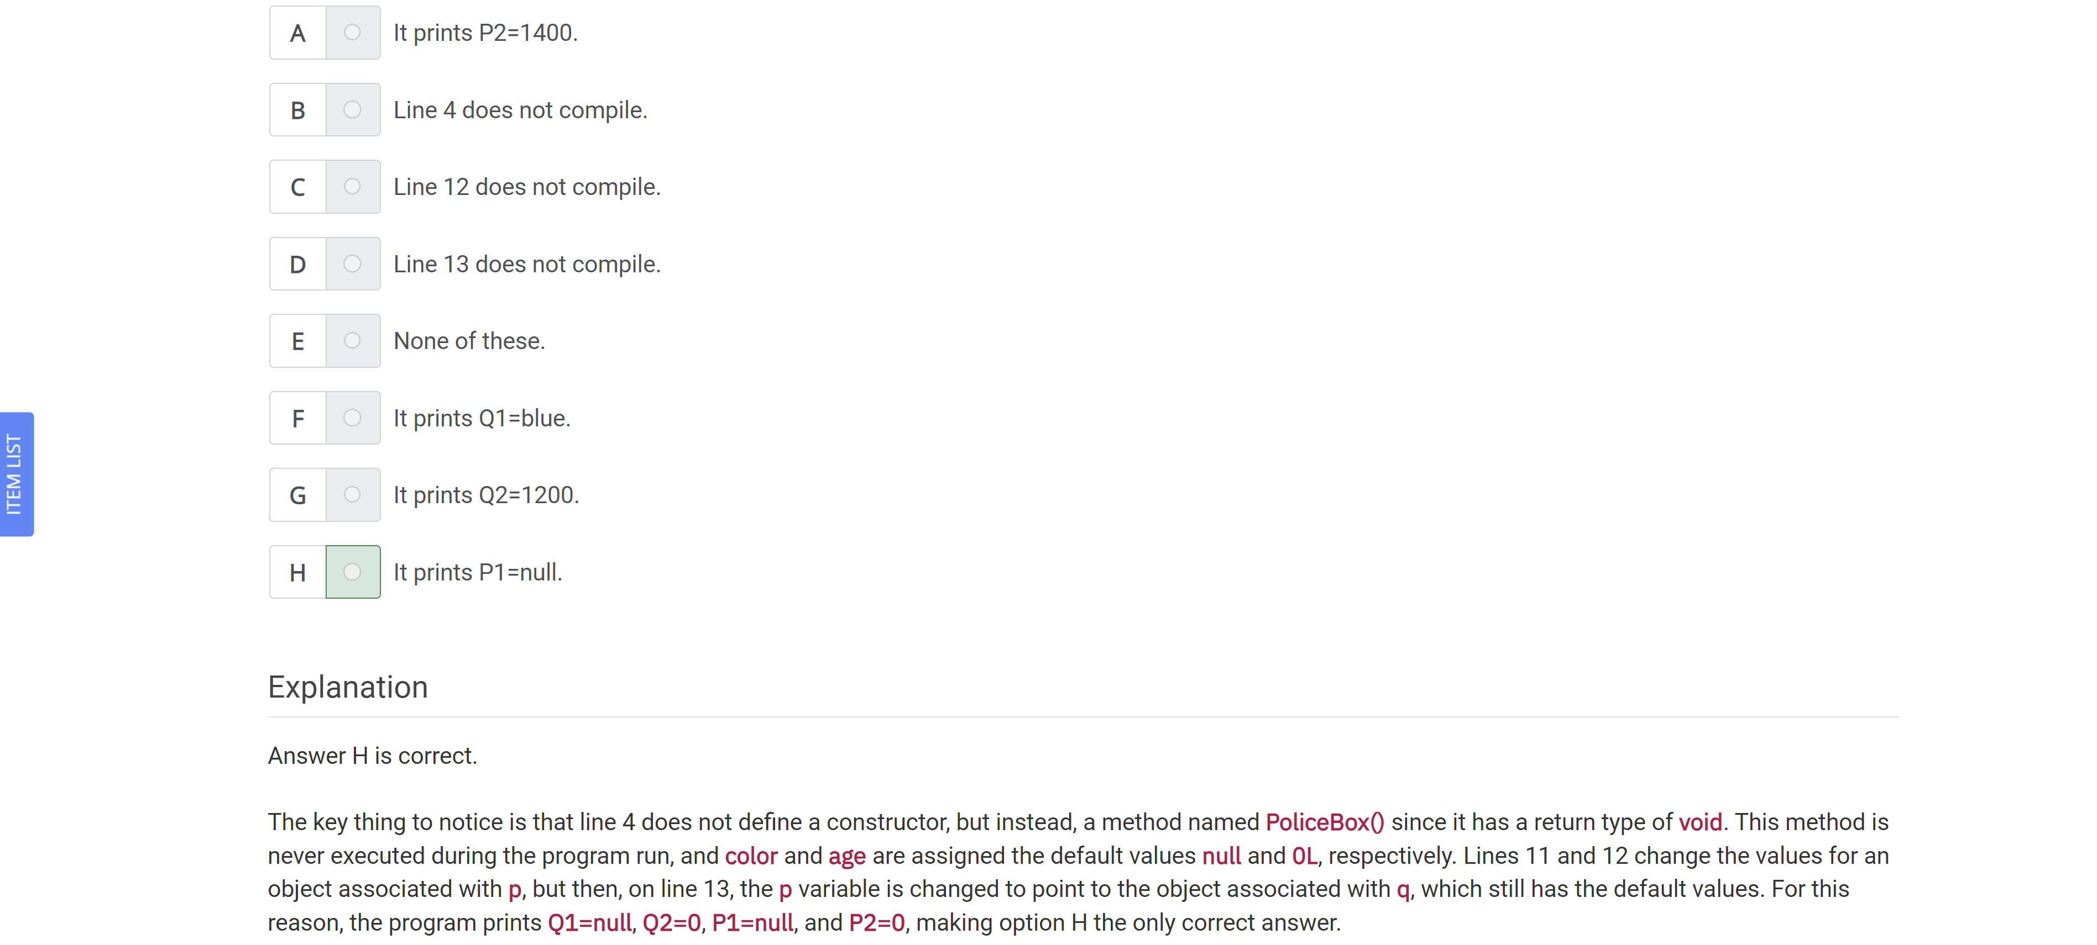

What data type (or types) will allow the following code snippet to compile?

Byte apples = 5;

Short oranges = 10;

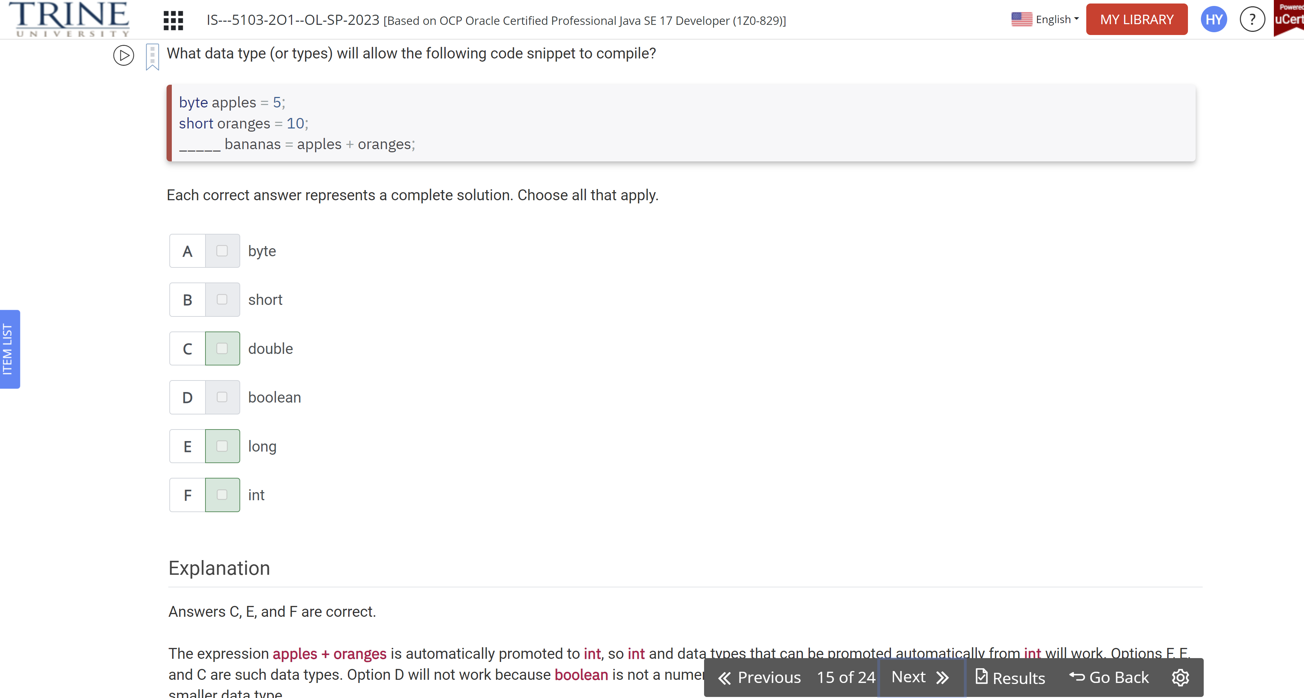

Which of the following expressions, when inserted independently into the blank line, allow the code to compile?

Public void printMagicData() { … }

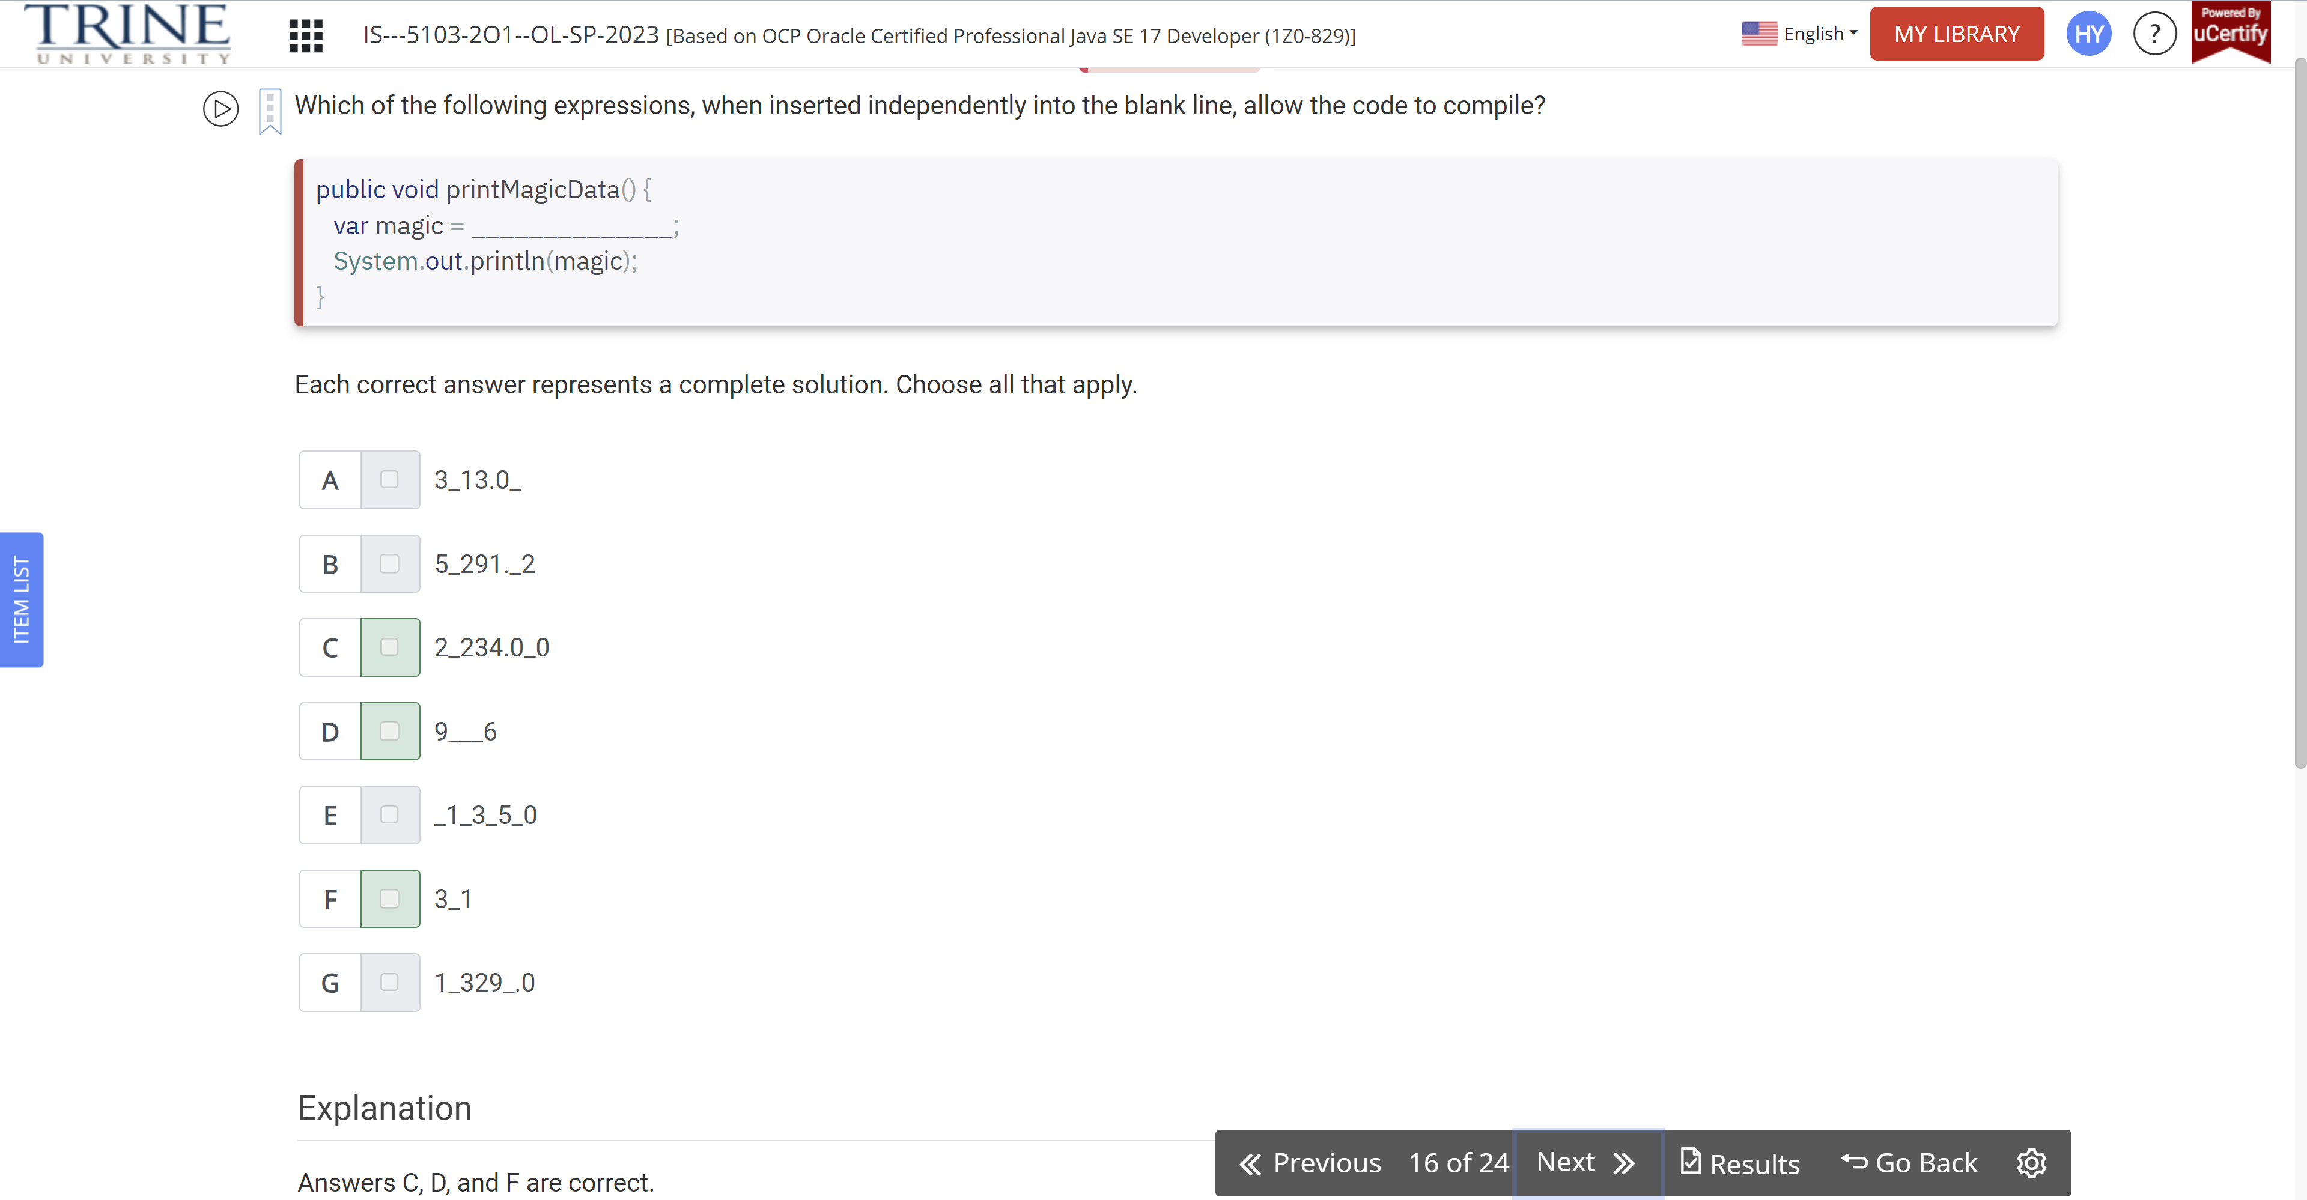

Which statements are true about the following code?

Var num1 = Long.parseLong(“100”);

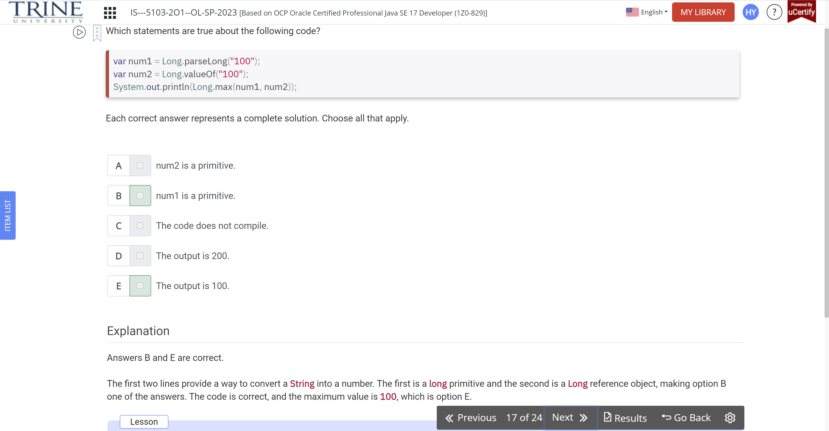

Which of the following are valid Java Identifiers?

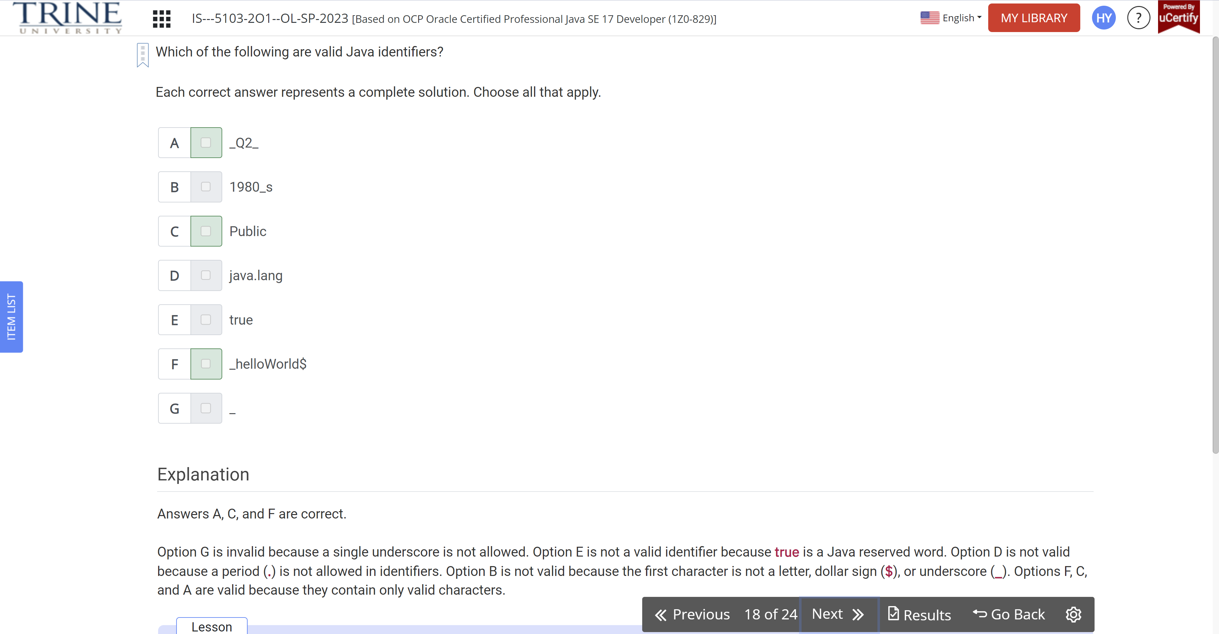

Which of the following statements is correct?

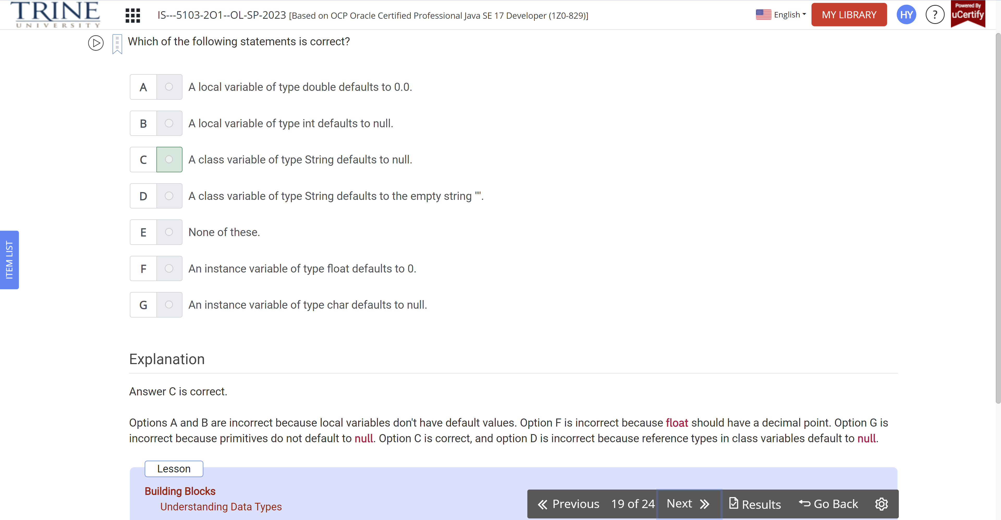

Which of the following statements are true?

Public class Bunny {…}

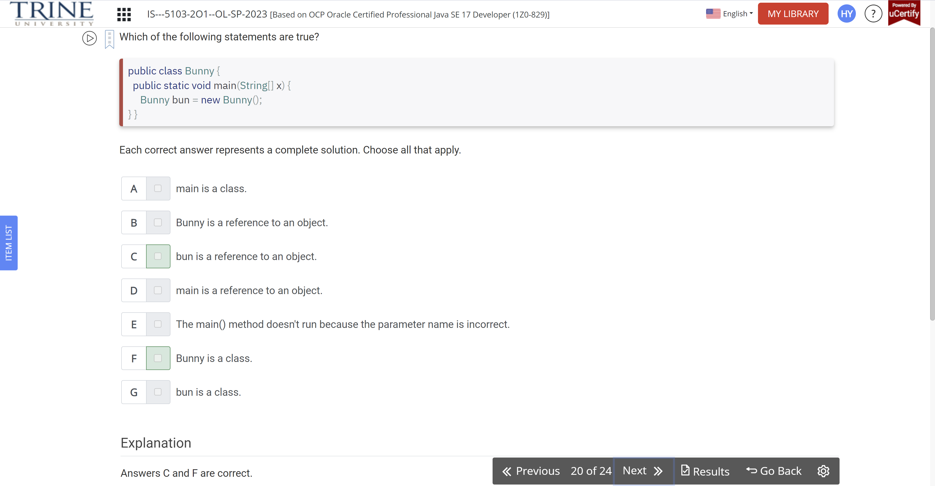

What lines are printed by the following program?

Public class WaterBottle {…}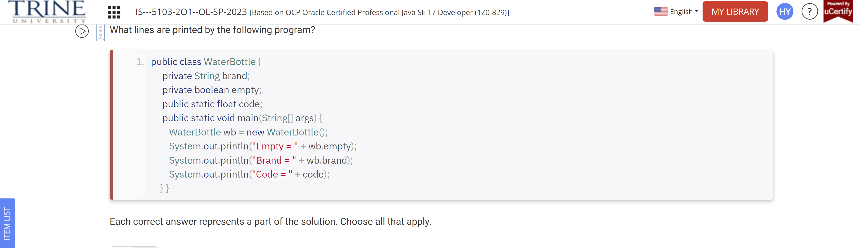

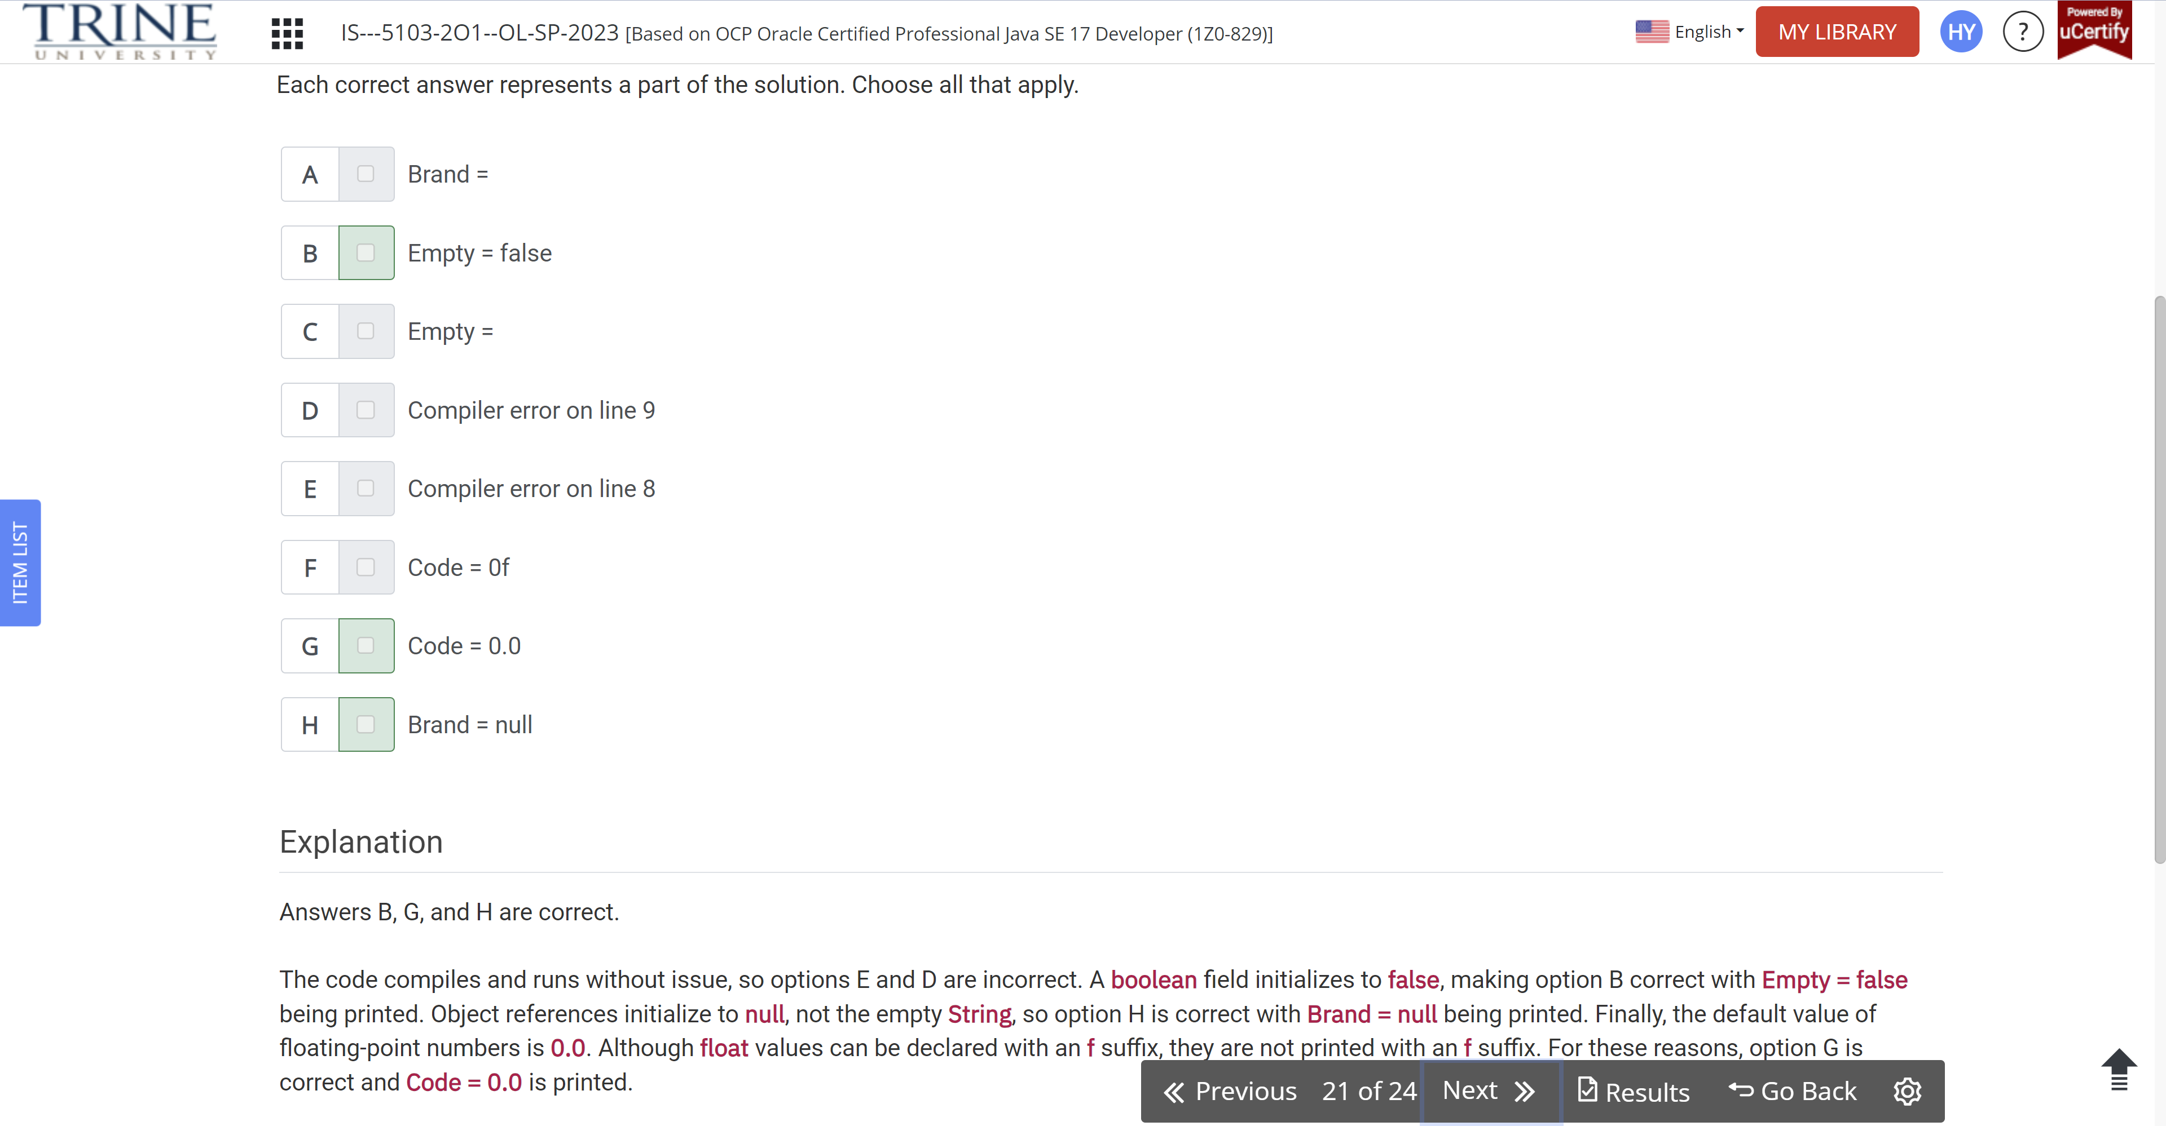

Which statements about the following class are correct?

Public class ClownFish {…}

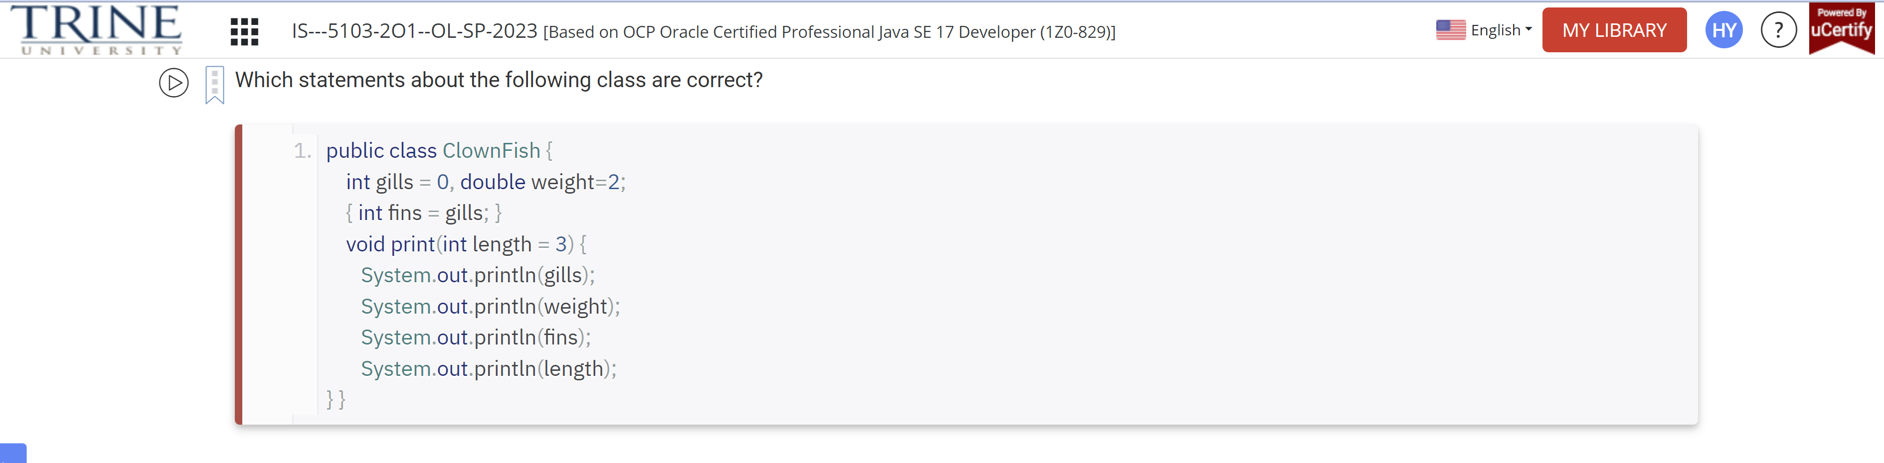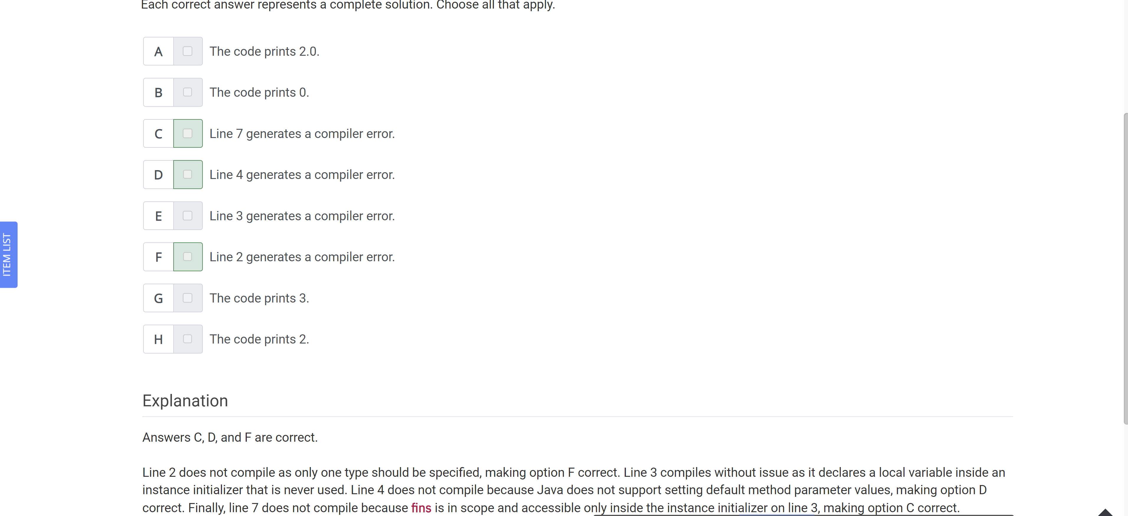

Which of these are true about this code?

Public class KitchenSink {…}

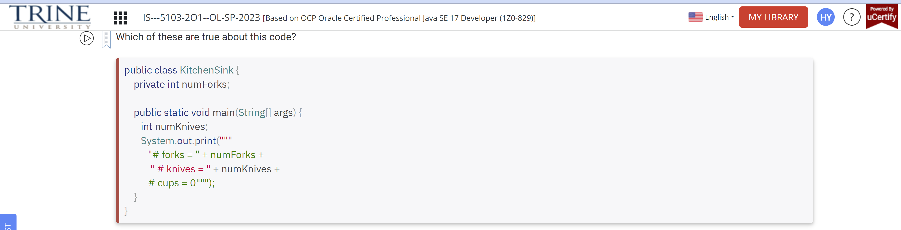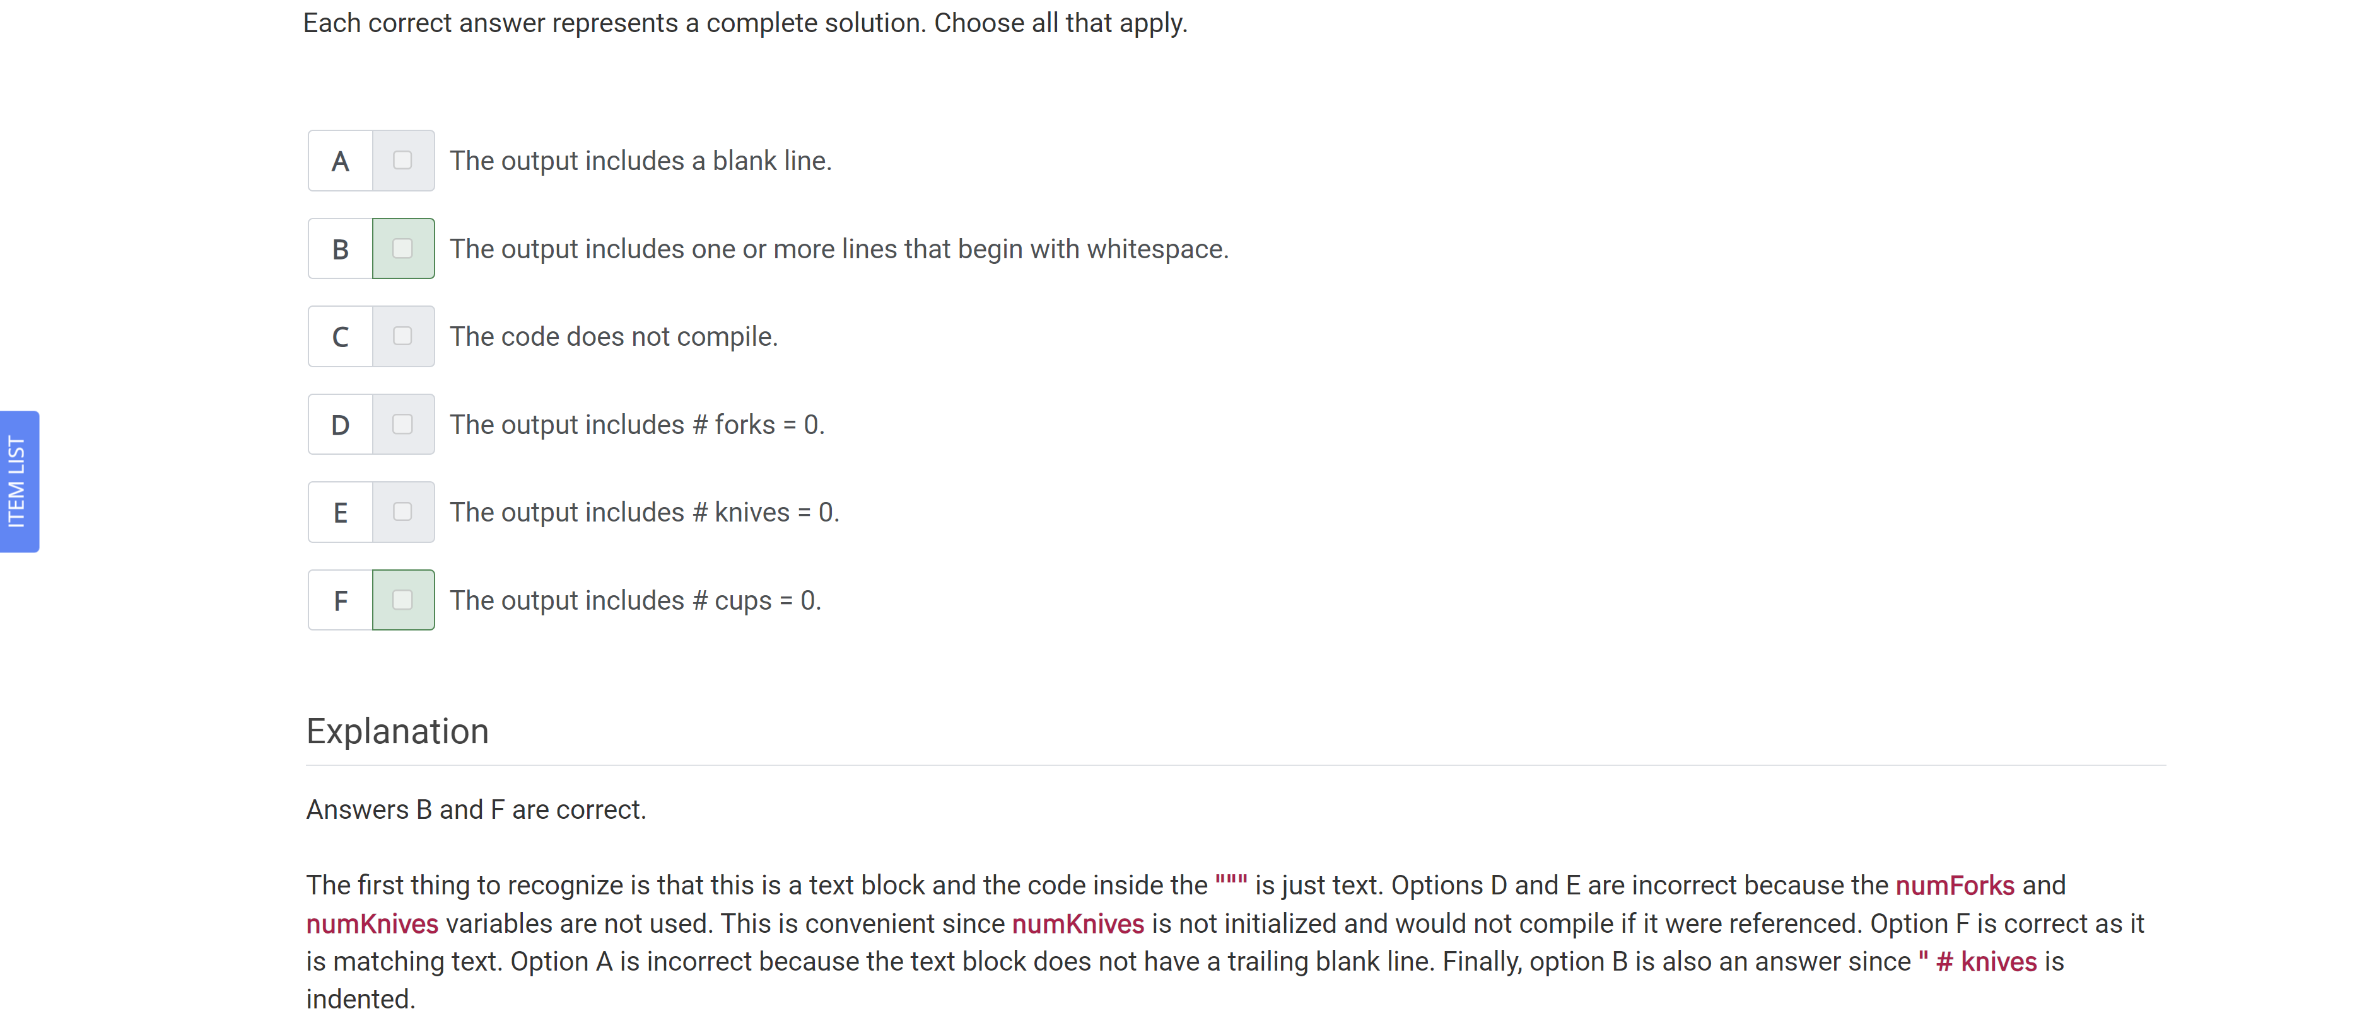

Which statements of the following program are correct?

Public class Bear {…}

